The Frontier of Spirituality!

New Adam/Eve

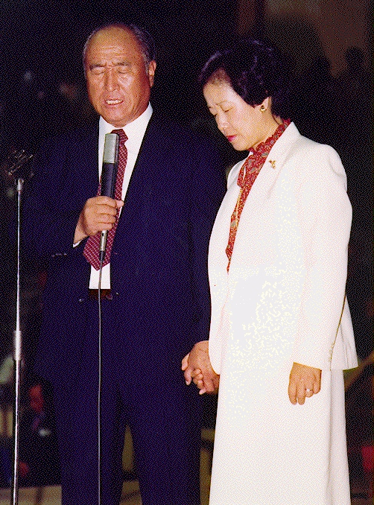
Dr. SunMyungMoon with his Holy Wife
Korea
Kaksi Todellista Ihmistä!
Yksi Tehtävä!

More about True Parents, their vision for World Peace
http://www.euro-tongil.org/finnish

www.euro-tongil.org/finnish

www.euro-tongil.org/finnish

www.euro-tongil.org/finnish

www.euro-tongil.org/finnish

www.euro-tongil.org/finnish

www.euro-tongil.org/finnish

www.euro-tongil.org/finnish

www.euro-tongil.org/finnish

www.euro-tongil.org/finnish

www.euro-tongil.org/finnish

www.euro-tongil.org/finnish

www.euro-tongil.org/finnish

www.euro-tongil.org/finnish

www.euro-tongil.org/finnish

www.euro-tongil.org/finnish

www.euro-tongil.org/finnish

www.euro-tongil.org/finnish

www.euro-tongil.org/finnish

www.euro-tongil.org/finnish

