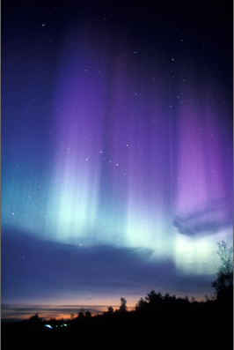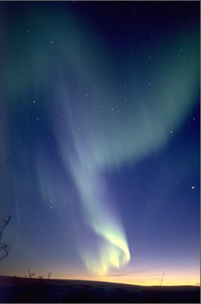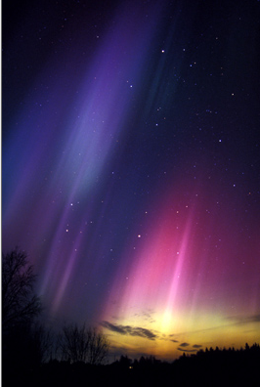
Natures Peaceful Beauty!

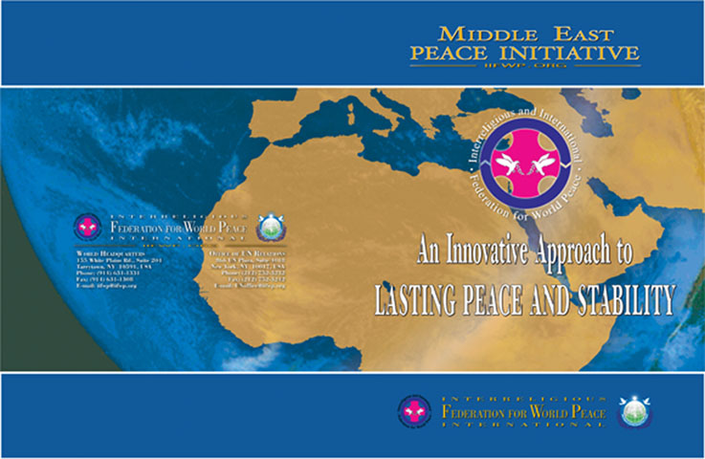

Peace in the Middle East!
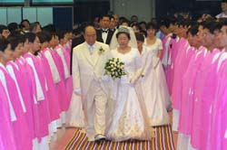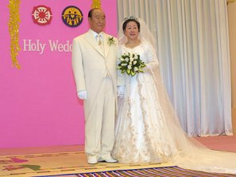
Founders SunMyung & HaJaHan Moon

www.euro-tongil.org/finnish

www.euro-tongil.org/finnish

www.euro-tongil.org/finnish

www.euro-tongil.org/finnish

www.euro-tongil.org/finnish

www.euro-tongil.org/finnish

www.euro-tongil.org/finnish

www.euro-tongil.org/finnish

www.euro-tongil.org/finnish

www.euro-tongil.org/finnish

www.euro-tongil.org/finnish

www.euro-tongil.org/finnish

www.euro-tongil.org/finnish

www.euro-tongil.org/finnish

www.euro-tongil.org/finnish

www.euro-tongil.org/finnish

www.euro-tongil.org/finnish

www.euro-tongil.org/finnish

www.euro-tongil.org/finnish

