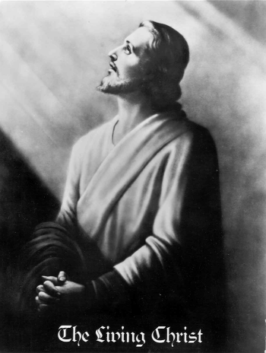
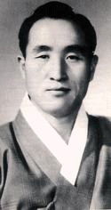
Sun Myung Moon Jesus
Korea Israel
1960
Kaksi Todellista Ihmistä!
Yksi Tehtävä!

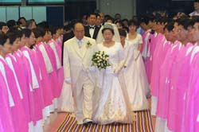

Marriage of the Lamb 2003
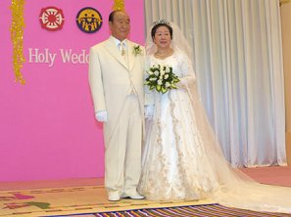

www.euro-tongil.org/finnish/

www.euro-tongil.org/finnish/

www.euro-tongil.org/finnish/

www.euro-tongil.org/finnish/

www.euro-tongil.org/finnish/

www.euro-tongil.org/finnish/

www.euro-tongil.org/finnish/

www.euro-tongil.org/finnish/

www.euro-tongil.org/finnish/

www.euro-tongil.org/finnish/

www.euro-tongil.org/finnish/

www.euro-tongil.org/finnish/

www.euro-tongil.org/finnish/

www.euro-tongil.org/finnish/

www.euro-tongil.org/finnish/

www.euro-tongil.org/finnish/

www.euro-tongil.org/finnish/

www.euro-tongil.org/finnish/

www.euro-tongil.org/finnish/

www.euro-tongil.org/finnish/

www.euro-tongil.org/finnish/

Rev 19:7

More about True Parents, their vision for World Peace
http://www.euro-tongil.org/finnish

