The Future of Science and Religion

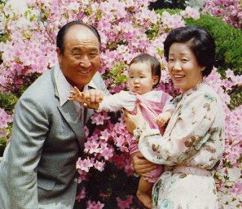 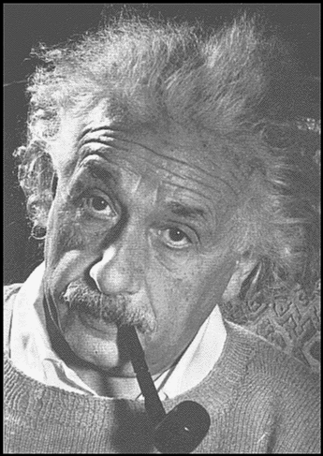
Religion and Science are Pursuing "Science without
the Unity of the Two Sides ! Religion is handicaped
/Rev Dr. SunMyungMoon and religion without science
is blind!
/Einstein 1879-1955

How will they be united? Even if there is some unified ideology that can unite the external and internal civilizations, they will not be brought together in an orderly manner. There will be forces of darkness which obstruct that task. Thus, we must first pass through a course of conflict to shatter them. This is the reason why today two last days doctrines are taking responsibility for one field. In other words, one is in charge of the internal aspect of God, and the other is symbolically responsible for the external aspect of God.

Because God gave people the responsibility to bring the comprehensive ideology of unification to pass, they have been developing the natural sciences, which research nature, into the form of one unified science. Through religion, they have been bringing together the world of the mind. The development of science today, in other words, the modern civilization centering on science, has been fulfilling the unified external ideology. This has reached the sphere of a unified ideology on the level of the world. After that, in the internal dimension, you must complete the mission of building the internal world in which humanity can become one through the religion which reveals, the mind or the original nature and character of human beings. /SMM

More about True Parents, their vision for World Peace!

www.euro-tongil.org/finnish

www.euro-tongil.org/finnish

www.euro-tongil.org/finnish

www.euro-tongil.org/finnish

www.euro-tongil.org/finnish

www.euro-tongil.org/finnish

www.euro-tongil.org/finnish

www.euro-tongil.org/finnish

www.euro-tongil.org/finnish

www.euro-tongil.org/finnish

www.euro-tongil.org/finnish

www.euro-tongil.org/finnish

www.euro-tongil.org/finnish

www.euro-tongil.org/finnish

www.euro-tongil.org/finnish

www.euro-tongil.org/finnish

www.euro-tongil.org/finnish

www.euro-tongil.org/finnish

www.euro-tongil.org/finnish

