The Frontier of
Spirituality!

New Adam/Eve
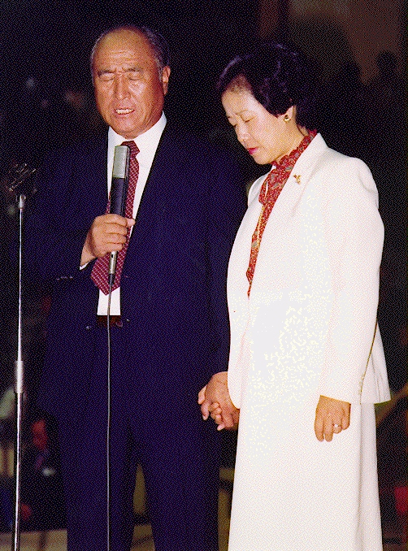
Dr. SunMyungMoon & Holy Wife
Korea

Einstein: ”Science without
religion is handicapped and
Religion without Science is
Blind!”
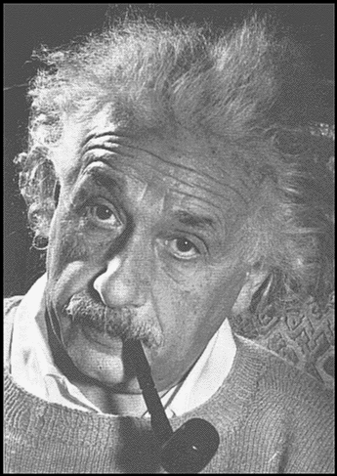
/Einstein 1879-1955

Religion and Science are pursuing the Unity of the
Two Sides!
/Rev Dr.SMM

More about True Parents, their vision for World Peace
http://www.euro-tongil.org/finnish



The Frontier of
Spirituality!

New Adam/Eve
Dr. SunMyungMoon & Holy Wife
Korea

Einstein: ”Science without
religion is handicapped and
Religion without Science is
Blind!”
/Einstein 1879-1955
Religion and Science are pursuing the Unity of the
Two Sides!
/Rev Dr.SMM

More about True Parents, their
vision for World Peace
http://www.euro-tongil.org/finnish

The Frontier of
Spirituality!

New Adam/Eve
Dr. SunMyungMoon & Holy Wife
Korea

Einstein: ”Science without
religion is handicapped and
Religion without Science is
Blind!”
/Einstein 1879-1955

Religion and Science are
pursuing the Unity of the
Two Sides!
/Rev Dr.SMM

More about True Parents, their
vision for World Peace
http://www.euro-tongil.org/finnish

