Kaunis Suomi
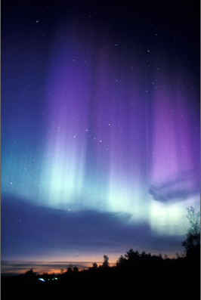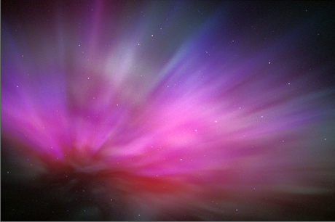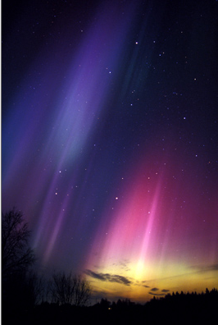
Natures Perfect Beauty
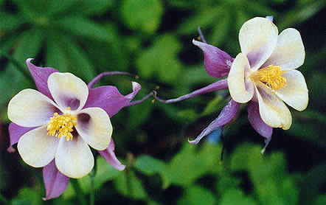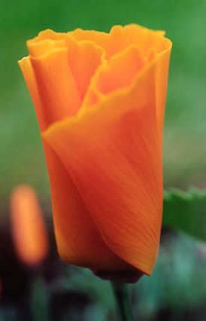

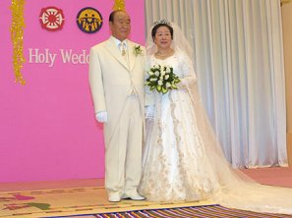
Holy & Perfect Human Beauty2003

www.euro-tongil.org/finnish

www.euro-tongil.org/finnish

www.euro-tongil.org/finnish

www.euro-tongil.org/finnish

www.euro-tongil.org/finnish

www.euro-tongil.org/finnish

www.euro-tongil.org/finnish

www.euro-tongil.org/finnish

www.euro-tongil.org/finnish

www.euro-tongil.org/finnish

www.euro-tongil.org/finnish

www.euro-tongil.org/finnish

www.euro-tongil.org/finnish

www.euro-tongil.org/finnish

www.euro-tongil.org/finnish

