2000 years
Time for 2nd Coming

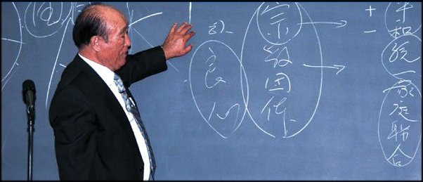

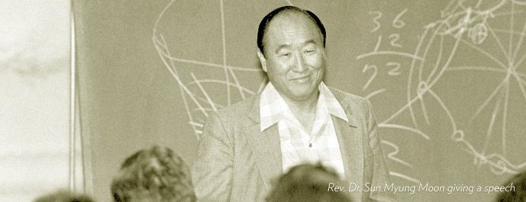

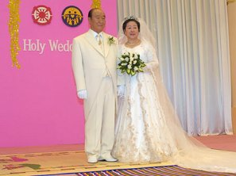
Henkistä valoa idästä!
www.euro-tongil.org/finnish/
www.euro-tongil.org/finnish/

www.euro-tongil.org/finnish/

www.euro-tongil.org/finnish/

www.euro-tongil.org/finnish/

www.euro-tongil.org/finnish/

www.euro-tongil.org/finnish/

www.euro-tongil.org/finnish/

www.euro-tongil.org/finnish/

www.euro-tongil.org/finnish/

www.euro-tongil.org/finnish/

www.euro-tongil.org/finnish/

www.euro-tongil.org/finnish/

www.euro-tongil.org/finnish/

