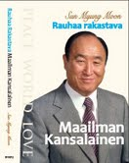
Father Moons
www.euro-tongil.org/
TFBiography/
Pihlajatie 42-44 B 85 Hki

Father Moons
www.euro-tongil.org/
TFBiography/
Pihlajatie 42-44 B 85 Hki

Father Moons
www.euro-tongil.org/
TFBiography/
Pihlajatie 42-44 B 85 Hki

Father Moons
Biography of

TRUE LOVE
www.euro-tongil.org/
TFBiography/
Pihlajatie 42-44 B 85 Hki

Father Moons
Biography of
TRUE LOVE
www.euro-tongil.org/
TFBiography/
Pihlajatie 42-44 B 85 Hki


Father Moon
www.euro-tongil.org/
TFBiography/
Pihlajatie 42-44 B 85 Hki

Father Moon
www.euro-tongil.org/
TFBiography/
Pihlajatie 42-44 B 85 Hki

Father Moon
www.euro-tongil.org/
TFBiography/
Pihlajatie 42-44 B 85 Hki

Father Moon
www.euro-tongil.org/
TFBiography/
Pihlajatie 42-44 B 85 Hki

Father Moon
www.euro-tongil.org/
TFBiography/
Pihlajatie 42-44 B 85 Hki

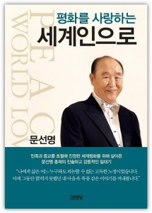
Father Moons
www.euro-tongil.org/
TFBiography/
Pihlajatie 42-44 B 85 Hki

Father Moons
www.euro-tongil.org/
TFBiography/
Pihlajatie 42-44 B 85 Hki

Father Moons
www.euro-tongil.org/
TFBiography/
Pihlajatie 42-44 B 85 Hki

Father Moons
www.euro-tongil.org/
TFBiography/
Pihlajatie 42-44 B 85 Hki

Father Moons
www.euro-tongil.org/
TFBiography/
Pihlajatie 42-44 B 85 Hki

