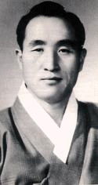
2000 Years of Waiting!
Time for 2nd Coming
www.euro-tongil.org/finnish
2000 Years of Waiting!
Time for 2nd Coming
www.euro-tongil.org/finnish
2000 Years of Waiting!
Time for 2nd Coming
www.euro-tongil.org/finnish
2000 Years of Waiting!
Time for 2nd Coming
www.euro-tongil.org/finnish

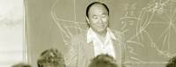

2000 Years of Waiting!
Time for 2nd Coming
www.euro-tongil.org/finnish

2000 Years of Waiting!
Time for 2nd Coming
www.euro-tongil.org/finnish

2000 Years of Waiting!
Time for 2nd Coming
www.euro-tongil.org/finnish

2000 Years of Waiting!
Time for 2nd Coming
www.euro-tongil.org/finnish

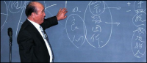
2000 Years of Waiting!
Time for a 2nd Coming
www.euro-tongil.org/finnish

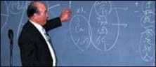
2000 Years of Waiting!
Time for 2nd Coming
www.euro-tongil.org/finnish

2000 Years of Waiting!
Time for 2nd Coming
www.euro-tongil.org/finnish

2000 Years of Waiting!
Time for 2nd Coming
www.euro-tongil.org/finnish

