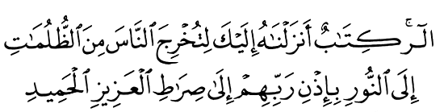
Imam - Mahdi



6 Febr 2003

Qur'an II,118

Vision for World Peace

www.euro-tongil.org/finnish
/English

www.euro-tongil.org/finnish/

www.euro-tongil.org/finnish/

www.euro-tongil.org/finnish/

www.euro-tongil.org/finnish/

www.euro-tongil.org/finnish/

www.euro-tongil.org/finnish/

www.euro-tongil.org/finnish/

www.euro-tongil.org/finnish/

www.euro-tongil.org/finnish/

www.euro-tongil.org/finnish/

www.euro-tongil.org/finnish/

www.euro-tongil.org/finnish/

www.euro-tongil.org/finnish/

www.euro-tongil.org/finnish/

www.euro-tongil.org/finnish/

