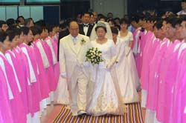

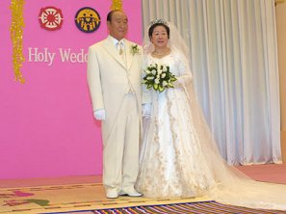Lammets Bröllop 2003
Upp 19:7

CROWN OF GLORY

When I doubt people, I feel pain.
When I judge people, it is unbearable.
When I hate people, there is no value to my existence.
Yet if I believe, I am deceived.
If I love, I am betrayed.
Suffering and grieving tonight, my head in my hands
Am I wrong?

Yes, I am wrong.
Even though we are deceived, still believe.
Though we are betrayed, still forgive.
Love completely even those who hate you.

Wipe your tears away and welcome with a smile
Those who know nothing but deceit
And those who betray without regret.
Oh Master! The pain of loving!
Look at my hands.
Place your hand on my chest.
My heart is bursting, such agony!

But when I loved those who acted against me
I brought victory.
If you have done the same thing,
I will give you the crown of glory.

/Sun Myung Moon, 16 år gammal

Sanna Föräldrar och deras vision för Världsfred
http://www.euro-tongil.org/swedish

www.euro-tongil.org/swedish/

www.euro-tongil.org/swedish/

www.euro-tongil.org/swedish/

www.euro-tongil.org/swedish/

www.euro-tongil.org/swedish/

www.euro-tongil.org/swedish/

www.euro-tongil.org/swedish/

www.euro-tongil.org/swedish/

www.euro-tongil.org/swedish/

www.euro-tongil.org/swedish/

www.euro-tongil.org/swedish/

www.euro-tongil.org/swedish/

www.euro-tongil.org/swedish/

www.euro-tongil.org/swedish/

www.euro-tongil.org/swedish/

www.euro-tongil.org/swedish/

www.euro-tongil.org/swedish/

www.euro-tongil.org/swedish/

www.euro-tongil.org/swedish/

www.euro-tongil.org/swedish/

www.euro-tongil.org/swedish/

www.euro-tongil.org/swedish/

www.euro-tongil.org/swedish/

www.euro-tongil.org/swedish/

www.euro-tongil.org/swedish/

www.euro-tongil.org/swedish/

www.euro-tongil.org/swedish/

