HOON DOK HAE – DAGLIG LÄSNING AV ANDLIGT INSPIRERANDE TEXTER!

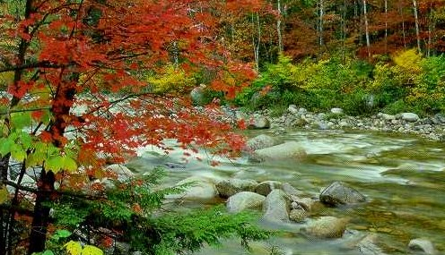

www.unification.org/ucbooks/HDH/index.html

www.unification.org/ucbooks/HDH/index.html

www.unification.org/ucbooks/HDH/index.html

www.unification.org/ucbooks/HDH/index.html

www.unification.org/ucbooks/HDH/index.html

www.unification.org/ucbooks/HDH/index.html

www.unification.org/ucbooks/HDH/index.html

www.unification.org/ucbooks/HDH/index.html

www.unification.org/ucbooks/HDH/index.html

www.unification.org/ucbooks/HDH/index.html

www.unification.org/ucbooks/HDH/index.html

www.unification.org/ucbooks/HDH/index.html

www.unification.org/ucbooks/HDH/index.html

www.unification.org/ucbooks/HDH/index.html

www.unification.org/ucbooks/HDH/index.html

www.unification.org/ucbooks/HDH/index.html

www.unification.org/ucbooks/HDH/index.html

www.unification.org/ucbooks/HDH/index.html

www.unification.org/ucbooks/HDH/index.html

www.unification.org/ucbooks/HDH/index.html

www.unification.org/ucbooks/HDH/index.html

www.unification.org/ucbooks/HDH/index.html

www.unification.org/ucbooks/HDH/index.html
www.unification.org/ucbooks/HDH/index.html
www.unification.org/ucbooks/HDH/index.html
www.unification.org/ucbooks/HDH/index.html
www.unification.org/ucbooks/HDH/index.html
www.unification.org/ucbooks/HDH/index.html
www.unification.org/ucbooks/HDH/index.html

HOON DOK HAE – DAGLIG LÄSNING AV ANDLIGT INSPIRERANDE TEXTER!

www.unification.org/ucbooks/HDH/index.html

www.unification.org/ucbooks/HDH/index.html

www.unification.org/ucbooks/HDH/index.html

www.unification.org/ucbooks/HDH/index.html

www.unification.org/ucbooks/HDH/index.html

www.unification.org/ucbooks/HDH/index.html

www.unification.org/ucbooks/HDH/index.html

www.unification.org/ucbooks/HDH/index.html

www.unification.org/ucbooks/HDH/index.html

www.unification.org/ucbooks/HDH/index.html

www.unification.org/ucbooks/HDH/index.html

www.unification.org/ucbooks/HDH/index.html

www.unification.org/ucbooks/HDH/index.html

www.unification.org/ucbooks/HDH/index.html

www.unification.org/ucbooks/HDH/index.html

www.unification.org/ucbooks/HDH/index.html

www.unification.org/ucbooks/HDH/index.html

www.unification.org/ucbooks/HDH/index.html

www.unification.org/ucbooks/HDH/index.html

www.unification.org/ucbooks/HDH/index.html

www.unification.org/ucbooks/HDH/index.html

www.unification.org/ucbooks/HDH/index.html

www.unification.org/ucbooks/HDH/index.html
www.unification.org/ucbooks/HDH/index.html
www.unification.org/ucbooks/HDH/index.html
www.unification.org/ucbooks/HDH/index.html
www.unification.org/ucbooks/HDH/index.html
www.unification.org/ucbooks/HDH/index.html
www.unification.org/ucbooks/HDH/index.html

