Imam - Mahdi

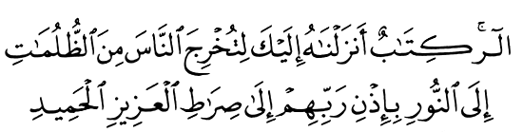
6 Febr 2003
Qur'an II,118
Vision for World Peace
www.euro-tongil.org/finnish

Imam - Mahdi
6 Febr 2003
Qur'an II,118
Vision for World Peace
www.euro-tongil.org/finnish

Imam - Mahdi
6 Febr 2003
Qur'an II,118
Vision for World Peace
www.euro-tongil.org/finnish

Imam - Mahdi

6 Febr 2003
Qur'an II,118
Vision for World Peace
www.euro-tongil.org/finnish

Imam - Mahdi

6 Febr 2003
Qur'an II,118
Vision for World Peace
www.euro-tongil.org/finnish

Imam - Mahdi

6 Febr 2003
Qur'an II,118
Vision for World Peace
www.euro-tongil.org/finnish

Imam - Mahdi

6 Febr 2003
Qur'an II,118
Vision for World Peace
www.euro-tongil.org/finnish

Imam - Mahdi

6 Febr 2003
Qur'an II,118
Vision for World Peace
www.euro-tongil.org/finnish

Imam - Mahdi

6 Febr 2003
Qur'an II,118
Vision for World Peace
www.euro-tongil.org/finnish

