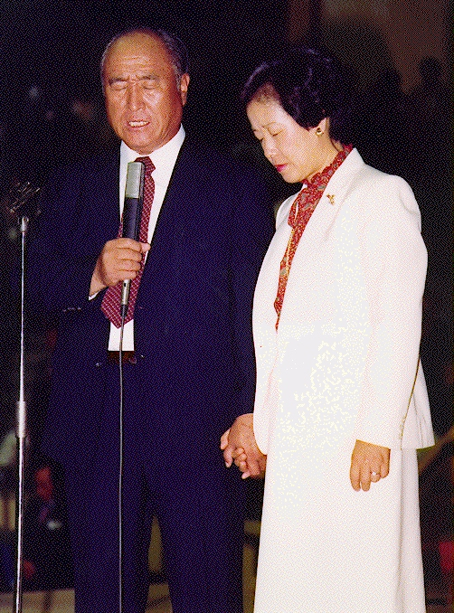
How do you understand this? Who?

Slavery in Egypt Period United Kingdom Divided Kingdom Babylonian Preparation for
of Judges Israel N/S Captivity Messiah

400 400 120 400 70+140 400

Abraham Moses Saul Malaki JESUS
12 sons blessed
70 relativs by Samuel

Persecution Regional Christian Empire Divided Kingdom Papal Exile Preparation for
in Roman Empire Church Leadership Europe E/W Messiah

400 400 120 400 70+140 400

JESUS Muhammad, Charlemagne Luther 2nd COMING
12 apostles Augustine blessed year 2000
70 disciples New. Test. by pope Leo III
Church
the incredible 2nd Coming in Korea!

Many have prophecied: Nostradamus, Edgar Cayce, Fatima, Jeane Dixon, Martinus, W.B. Yeats, Besant, Bailey, A. Ford

MY ADVENTURE INTO THE MEDITATIVE DIMENSION by Arthur Ford (1879-1971)

Mr. Moon in deep meditation can project himself and be seen just as Jesus has been able to project himself and be seen by the saints. This is one of the marks - of the messiahs always.

Hear the word and do not allow tradition to blind you to revelation.
In the Book of Revelation there is a picture of the New Jerusalem, the Holy City, coming down out of the heavens. And when the teacher comes, he always has to come through
the eastern gate. In the Holy City of Jerusalem there is an eastern gate long since sealed and blocked. It will never be opened until the new teacher comes.

The Jesus of Galilee will not return - it is not necessary.
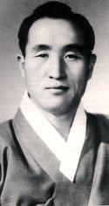
Sun Myung Moon

www.euro-tongil.org/swedish/english/
www.euro-tongil.org/swedish/english/
www.euro-tongil.org/swedish/english/
www.euro-tongil.org/swedish/english/
www.euro-tongil.org/swedish/english/
www.euro-tongil.org/swedish/english/
www.euro-tongil.org/swedish/english/
www.euro-tongil.org/swedish/english/
www.euro-tongil.org/swedish/english/
www.euro-tongil.org/swedish/english/
www.euro-tongil.org/swedish/english/
www.euro-tongil.org/swedish/english/
www.euro-tongil.org/swedish/english/
www.euro-tongil.org/swedish/english/
www.euro-tongil.org/swedish/english/
www.euro-tongil.org/swedish/english/
www.euro-tongil.org/swedish/english/
www.euro-tongil.org/swedish/english/
www.euro-tongil.org/swedish/english/
www.euro-tongil.org/swedish/english/
www.euro-tongil.org/swedish/english/
www.euro-tongil.org/swedish/english/
www.euro-tongil.org/swedish/english/
www.euro-tongil.org/swedish/english/
www.euro-tongil.org/swedish/english/
www.euro-tongil.org/swedish/english/
www.euro-tongil.org/swedish/english/
www.euro-tongil.org/swedish/english/
www.euro-tongil.org/swedish/english/
www.euro-tongil.org/swedish/english/
www.euro-tongil.org/swedish/english/
www.euro-tongil.org/swedish/english/
www.euro-tongil.org/swedish/english/
www.euro-tongil.org/swedish/english/
www.euro-tongil.org/swedish/english/
www.euro-tongil.org/swedish/english/
www.euro-tongil.org/swedish/english/
www.euro-tongil.org/swedish/english/
www.euro-tongil.org/swedish/english/
www.euro-tongil.org/swedish/english/
www.euro-tongil.org/swedish/english/

