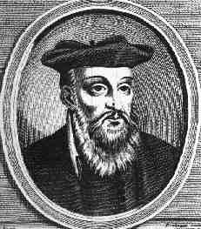
”Long awaited he will never return in Europe. Nostradamus prophesied that Christ,
He will appear in Asia; would come from the East, not Europe,
One of the league issued from great Hermes, where be has been long awaited,
He will grow above all other powers in the Orient.” and that his influence would be felt by everyone..

In the coming years... the RETURN OF CHRIST will take place,
and all shall see him!

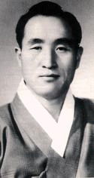

Read more about the Second Coming!
www.euro-tongil.org/finnish

www.euro-tongil.org/finnish/

www.euro-tongil.org/finnish/

www.euro-tongil.org/finnish/

www.euro-tongil.org/finnish/

www.euro-tongil.org/finnish/

www.euro-tongil.org/finnish/

www.euro-tongil.org/finnish/

www.euro-tongil.org/finnish/

www.euro-tongil.org/finnish/

www.euro-tongil.org/finnish/

www.euro-tongil.org/finnish/

www.euro-tongil.org/finnish/

www.euro-tongil.org/finnish/

www.euro-tongil.org/finnish/

www.euro-tongil.org/finnish/

www.euro-tongil.org/finnish/

www.euro-tongil.org/finnish/

www.euro-tongil.org/finnish/

www.euro-tongil.org/finnish/

www.euro-tongil.org/finnish/

www.euro-tongil.org/finnish/

www.euro-tongil.org/finnish/

www.euro-tongil.org/finnish/

www.euro-tongil.org/finnish/

www.euro-tongil.org/finnish/

www.euro-tongil.org/finnish/

www.euro-tongil.org/finnish/

www.euro-tongil.org/finnish/

www.euro-tongil.org/finnish/

www.euro-tongil.org/finnish/

