
Revelation 1935-2003
DIVINE PRINCIPLE

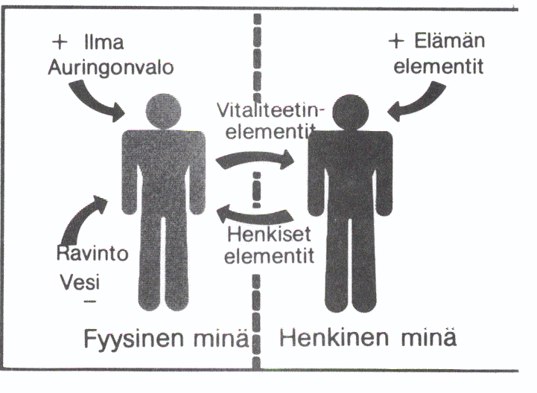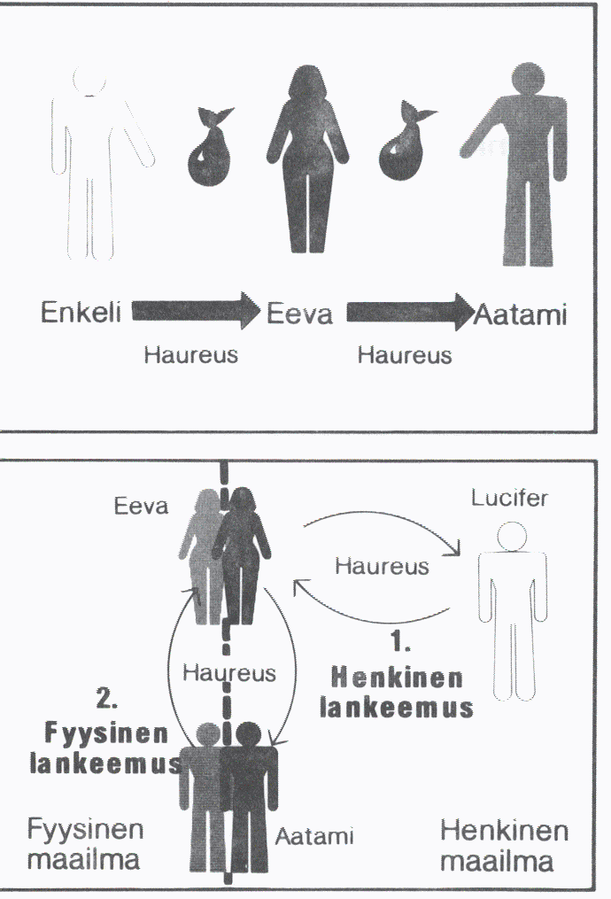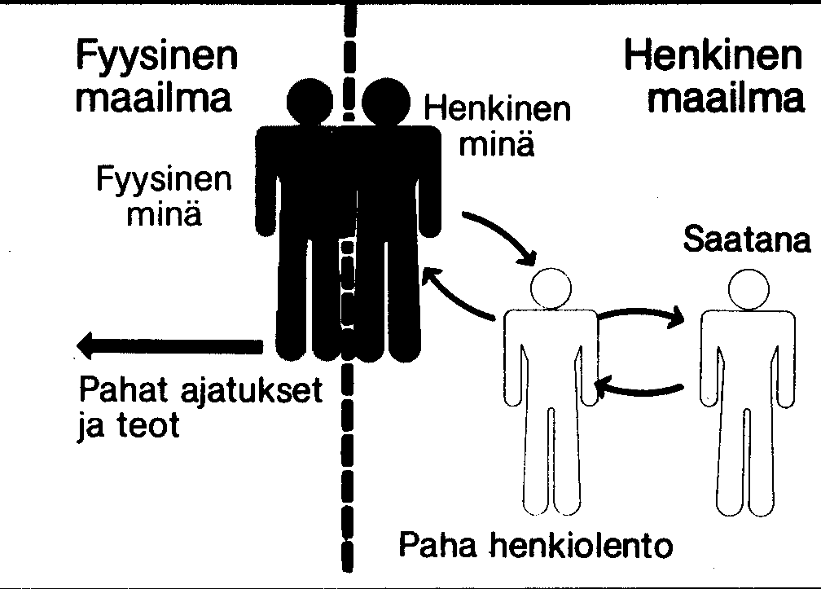

www.euro-tongil.
org/finnish

www.euro-tongil.
org/finnish

www.euro-tongil.
org/finnish

www.euro-tongil.
org/finnish

www.euro-tongil.
org/finnish

www.euro-tongil.
org/finnish

www.euro-tongil.
org/finnish

www.euro-tongil.
org/finnish

