True Love and Beauty from the Orient

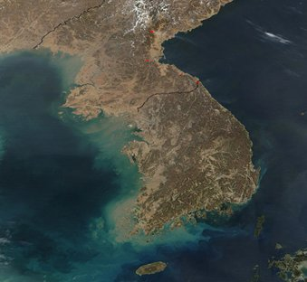

A United Korea = New Holy Israel!

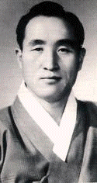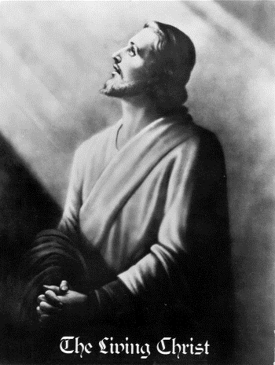
3rd Adam! 1960-2013 2nd Holy Adam!
2000 years ago



The Return of Christ

True Parents World Peace Kingdom for YOU!
More about their vision for Absolute Global World Peace

