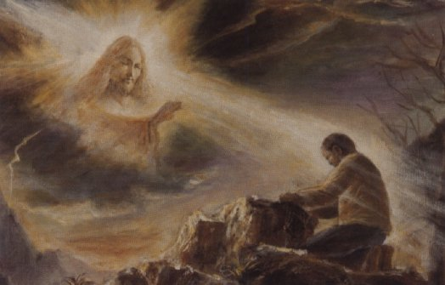
Revelations 1935 -

Time Parallels between Our Age and Jesus Age
Rev 19:7

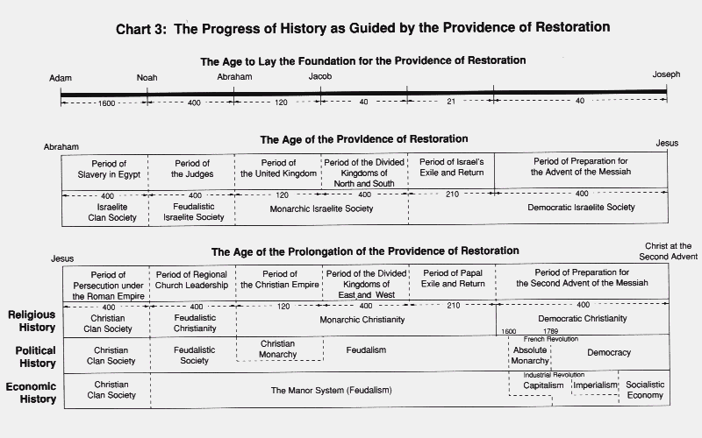

More about True Parents, their vision for World Peace

http://www.euro-tongil.org/finnish/

www.euro-tongil.org/finnish

www.euro-tongil.org/finnish

www.euro-tongil.org/finnish

www.euro-tongil.org/finnish

www.euro-tongil.org/finnish

www.euro-tongil.org/finnish

www.euro-tongil.org/finnish

www.euro-tongil.org/finnish

www.euro-tongil.org/finnish

www.euro-tongil.org/finnish

www.euro-tongil.org/finnish

www.euro-tongil.org/finnish

www.euro-tongil.org/finnish

www.euro-tongil.org/finnish

www.euro-tongil.org/finnish

www.euro-tongil.org/finnish

www.euro-tongil.org/finnish

www.euro-tongil.org/finnish

www.euro-tongil.org/finnish

