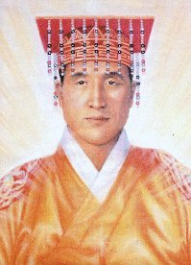
Truth from the Orient
The New Buddha 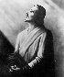
Spiritual painting of the new Buddha to come, Maitreya Buddha,
done by american artist Nanette Crist Johnson.

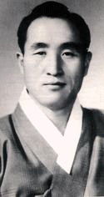
Picture of korean Sun Myung Moon from 1960

Guatama Buddha predicted the arriveal of the Maitreya in this time period. Unlike previous Buddhas, the Buddha of this Age will bring enlightenment to the masses as compared to the individual. Here is a shining depiction of the walthy family man who represents abundance and True Love in the family unit. Shown in full ceremonial dress the Maitreya Buddha creates the foundation for the Ideal Society of the Golden Age. Meditation on this portrait enables the viewer to resonate to the qualities of Divine Will, Unconditional Love and Planetary Healing.
From the east comes mysticism - a willingness to be absorbed in God - God is not something apart - he is something within. From the south comes all the beauty, the ritual - these things which adorn and make beautiful the message. From the north came rational thought clear thinking - reformation - and change. From the west came the critical, scientific analysis.
And now in the New Age, it is an age of orchestration - of a symphony - of unity. And the New Teacher will be neither Christian, Buddhist, Moslem, or anything else. The Holy Spirit speaks in universal terms - and God will no longer be fragmented.

For more information, contact Family Federation for World Peace Finland
http://www.euro-tongil.org/finnish

www.euro-tongil.org
/finnish/

www.euro-tongil.org
/finnish/

www.euro-tongil.org
/finnish/

www.euro-tongil.org
/finnish/

www.euro-tongil.org
/finnish/

www.euro-tongil.org
/finnish/

www.euro-tongil.org
/finnish/

www.euro-tongil.org
/finnish/

www.euro-tongil.org
/finnish/

www.euro-tongil.org
/finnish/

www.euro-tongil.org
/finnish/

www.euro-tongil.org
/finnish/

www.euro-tongil.org
/finnish/

www.euro-tongil.org
/finnish/

www.euro-tongil.org
/finnish/

www.euro-tongil.org
/finnish/

www.euro-tongil.org
/finnish/

www.euro-tongil.org
/finnish/

