Nostradamus prophecies will be fulfilled
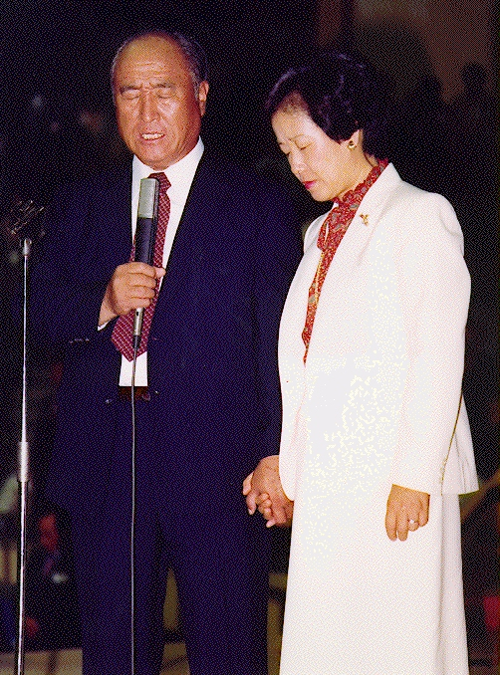
in the coming decade 2000
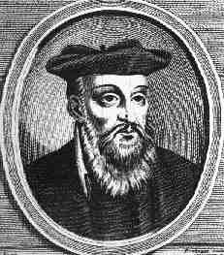
”Long awaited he will never return in Europe. Nostradamus prophesied that Christ,
He will appear in Asia; would come from the East, not Europe,
One of the league issued from great Hermes, where be has been long awaited,
He will grow above all other powers in the Orient.” and that his influence would be felt by everyone..

2012 Maya calender & Kalevala

Why did the ancient Mayan or pre-Maya choose December 21st, 2012 A.D., as the end of their Long Count calendar? Scholars have known for decades that the 13-baktun cycle of the Mayan "Long Count" system of timekeeping was set to end precisely on a winter solstice, and that this system was put in place some 2300 years ago. This amazing fact - that ancient Mesoameri- can skywatchers were able to pinpoint a winter solstice far off into the future - has not been dealt with by Mayanists. And why did they choose the year 2012?

The mysterious existence of myths obviously describing precession in the ancient verses of the Kalevala, the Finnish National Epic. These myths were relayed from the earliest times by way of singers. Many of these stories are thoroughly magical and are filled with sky lore. The Finnish language is not of Indo- European origin and up until the late 19th century peasants in Finland and northwestern Russia had little contact with Europe. Indeed, their heritage suggests more contact with Central Asia than Europe. Some of the Kalevala stories describe a sacred Mill called the Sampo (derived from sanskrit Skambha = pillar or pole) with a "many ciphered cover". This spinning Mill is a metaphor for a Golden Age of plenty and the starry sky spinning around the Pole Star (known as the Nail of the North), which in the Far North is almost straight over head. The Mill at some point is disturbed, its pillar being pulled out of its peg, and a new one - a new "age" - must be constructed!

Nostradamus, Arthur Ford, Edgar Cayce , Fatima prophecies,

Korean Prophecies and Sun Myung Moons life!

They all share the similar message:

the RETURN OF CHRIST is taking place NOW,
in our time and all shall see him!

Read more about the Second Coming of CHRIST!
www.euro-tongil.org/finnish

www.euro-tongil.org/finnish/

www.euro-tongil.org/finnish/

www.euro-tongil.org/finnish/

www.euro-tongil.org/finnish/

www.euro-tongil.org/finnish/

www.euro-tongil.org/finnish/

www.euro-tongil.org/finnish/

www.euro-tongil.org/finnish/

www.euro-tongil.org/finnish/

www.euro-tongil.org/finnish/

www.euro-tongil.org/finnish/

www.euro-tongil.org/finnish/

www.euro-tongil.org/finnish/

www.euro-tongil.org/finnish/

www.euro-tongil.org/finnish/

www.euro-tongil.org/finnish/

www.euro-tongil.org/finnish/

www.euro-tongil.org/finnish/

www.euro-tongil.org/finnish/

www.euro-tongil.org/finnish/

www.euro-tongil.org/finnish/

www.euro-tongil.org/finnish/

