Nostradamus prophecies will be fulfilled
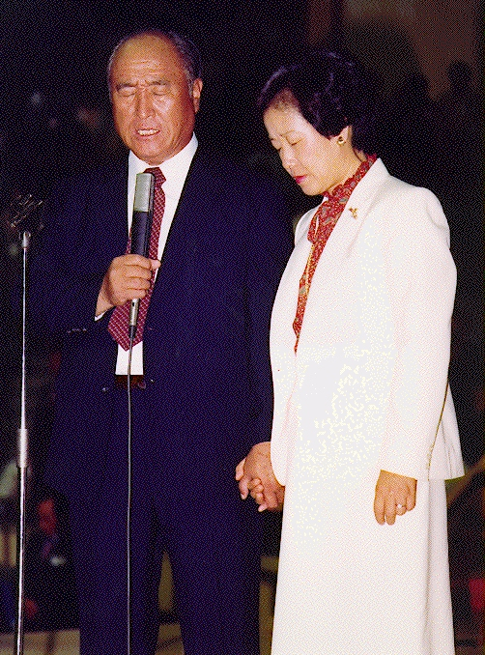
in the coming decade 2000
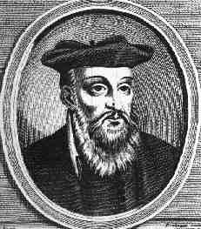

”Long awaited he will never return in Europe. Nostradamus prophesied that Christ,
He will appear in Asia; would come from the East, not Europe,
One of the league issued from great Hermes, where be has been long awaited,
He will grow above all other powers in the Orient.” and that his influence would be felt by everyone..

The Millennium

Most prophecies are focused on being fulfilled in the years 2000...

Nostradamus, Arthur Ford, Edgar Cayce , Jeane Dixon, W.B. Yeats, Pope John the 23rd A. Brooke, Fatima, Martinus, Annie Besant, Alice Bailey

Korean Prophecies and Sun Myung Moon!

They all share the similar message:

In the millenium 2000... the RETURN OF CHRIST will take place,
and all shall see him!

Read more about the Second Coming!
www.euro-tongil.org/english

www.euro-tongil.org/english/

www.euro-tongil.org/english/

www.euro-tongil.org/english/

www.euro-tongil.org/english/

www.euro-tongil.org/english/

www.euro-tongil.org/english/

www.euro-tongil.org/english/

www.euro-tongil.org/english/

www.euro-tongil.org/english/

www.euro-tongil.org/english/

www.euro-tongil.org/english/

www.euro-tongil.org/english/

www.euro-tongil.org/english/

www.euro-tongil.org/english/

www.euro-tongil.org/english/

www.euro-tongil.org/english/

www.euro-tongil.org/english/

www.euro-tongil.org/english/

www.euro-tongil.org/english/

www.euro-tongil.org/english/

www.euro-tongil.org/english/

www.euro-tongil.org/english/

www.euro-tongil.org/english/

www.euro-tongil.org/english/

www.euro-tongil.org/english/

www.euro-tongil.org/english/

www.euro-tongil.org/english/

www.euro-tongil.org/english/

www.euro-tongil.org/english/

www.euro-tongil.org/english/

