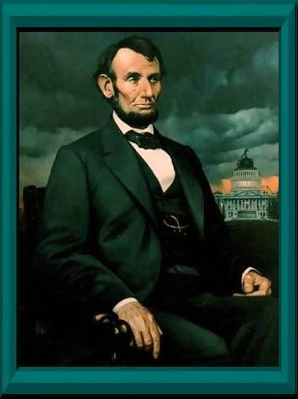

Abraham Lincoln (1861-1865)

Sixteenth President of the United States;
Preserved the Union through victory in the Civil War, and issued the Proclamation of Emancipation for the slaves

People of America, I wish for you to constantly go the way of obedience, aligned with the teachings of True Parents.
Rev. Sun Myung Moon, Mansei!

Returning Lord and Messiah, Mansei!

True Parents of humanity, Mansei!

I, Abraham Lincoln, have experienced incredibly wondrous and exciting moments, but I am saddened that there is no communication, or crossing back and forth, between the earthly and spiritual worlds. Without doubt, Rev. Sun Myung Moon is the True Parent of humanity. He shows us how to love one another and brings us together as one, with no discrimination among religions or races. He is accomplishing feats on many levels that would be utterly impossible if it were not for True Parents' teachings. People of America, do you think you can bring peace through war and military force? God has appeared before humankind as our parent. While I was listening to the Divine Principle lectures, I had a vision. In this vision, all the souls in this place, including black people, yellow people, and white people, and including Christians, Buddhists, Confucianists, and Muslims, all came together and danced for joy. Then I saw a bright light, that is, the brilliant light of God, and in that instant, I, Abraham Lincoln, wanted to also jump in among them and begin to dance.

People of America, people of the world! Black people are children of God, as are white people. At some time, all of you will have to gather here in the spirit world and walk side by side and live together. I simply came here and experienced this fact before you.

I am making a request to the people of America because I love you with an earnest heart. Rev. Sun Myung Moon has appeared as the Messiah and the True Parent of humankind. I hope that you will attend the Messiah and constantly walk the path of obedience based on True Parents' teachings. War and military force will only serve to create another human hell. Is it not time for the earthly world to declare an end to hell? A philosophy of peace for humankind comes from the Messiah. The life that you now live in the earthly world is only a fleeting and incomplete life. If you are to live in the eternal world with eternal happiness, you must above all else awaken to the truth of the Divine Principle and Unification Thought. This is my solemn request.

Rev. Sun Myung Moon, I respect you. I thank you very much for all you have done. I will attend you resolutely as the Messiah and returning Lord, tear down the walls between races and religious groups, and participate actively in True Parents' Unification Movement.

www.euro-tongil.org/swedish/english/
www.euro-tongil.org/swedish/english/
www.euro-tongil.org/swedish/english/
www.euro-tongil.org/swedish/english/
www.euro-tongil.org/swedish/english/
www.euro-tongil.org/swedish/english/
www.euro-tongil.org/swedish/english/
www.euro-tongil.org/swedish/english/
www.euro-tongil.org/swedish/english/
www.euro-tongil.org/swedish/english/
www.euro-tongil.org/swedish/english/
www.euro-tongil.org/swedish/english/
www.euro-tongil.org/swedish/english/
www.euro-tongil.org/swedish/english/
www.euro-tongil.org/swedish/english/
www.euro-tongil.org/swedish/english/
www.euro-tongil.org/swedish/english/
www.euro-tongil.org/swedish/english/
www.euro-tongil.org/swedish/english/
www.euro-tongil.org/swedish/english/
www.euro-tongil.org/swedish/english/
www.euro-tongil.org/swedish/english/
www.euro-tongil.org/swedish/english/
www.euro-tongil.org/swedish/english/
www.euro-tongil.org/swedish/english/
www.euro-tongil.org/swedish/english/
www.euro-tongil.org/swedish/english/
www.euro-tongil.org/swedish/english/
www.euro-tongil.org/swedish/english/
www.euro-tongil.org/swedish/english/
www.euro-tongil.org/swedish/english/
www.euro-tongil.org/swedish/english/
www.euro-tongil.org/swedish/english/
www.euro-tongil.org/swedish/english/
www.euro-tongil.org/swedish/english/
www.euro-tongil.org/swedish/english/
www.euro-tongil.org/swedish/english/
www.euro-tongil.org/swedish/english/
www.euro-tongil.org/swedish/english/
www.euro-tongil.org/swedish/english/
www.euro-tongil.org/swedish/english/

Abraham Lincoln; December 9, 2002

