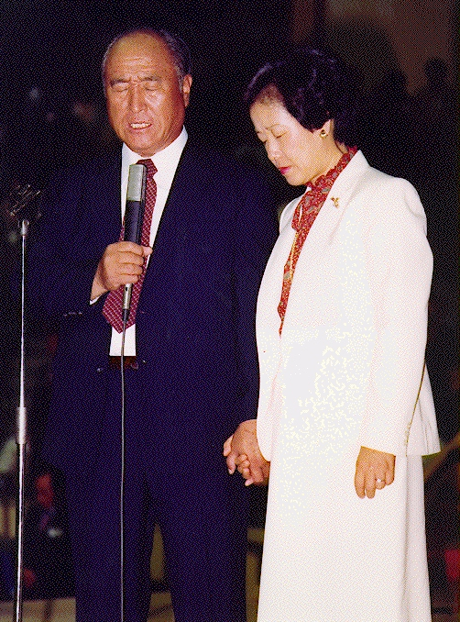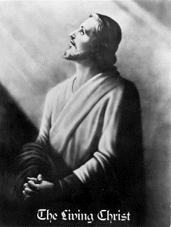

THE RETURN OF CHRIST, MESSIAH (Jews),IMAM/MAHDI (Muslims), MAITREYA (Budhists)
IS TAKING PLACE RIGHT NOW THROUGH A SINLESS KOREAN COUPLE

ABRAHAMS FAMILY = ISAK + ISHMAEL = JEWS/CHRISTIANS + MUSLIMS

Mohammed's Message for Muslims and People on Earth
When God created human beings, each individual was to be an object of joy to Him. However, against His original will, due to the fall of the first human ancestors, from the beginning human history flowed in a wrong direction. Races divided, religions arose, and different cultures developed depending on the living environment. Nevertheless, the Creator of all human beings is only one, God. How painful His heart must be when He looks at the divisions of humankind into many races, religions and cultures. God is the Parent of all humanity, but when He has to watch His children fighting everyday, arguing over who is right and who is wrong, how must He feel? Earthly people do not know the overall direction and flow of God's providence, nor the relationship between God and human beings, and that is why there has been no harmony among religions for a long time.
God is the Parent of humanity. If examined carefully, the original source of all doctrine or truth is one. What religion would teach people to revere evil. Although their methods might differ, their fundamental purpose is to pursue goodness. Because God is the original being of absolute goodness and love, and every religion teaches about love.
Therefore, the fundamental teachings of each religion are quite similar. Now God's basic desires are to bring the truths and doctrines of all religions together and unite them as one. When it is done, God can finally rest. After countless days of waiting, God finally sent Reverend Sun Myung Moon for this purpose. Through him, the Unification Principle was revealed for the sake of the unification of all religions.
Dear Muslims, you too were born as children of God. I hope that you will unite in one thought. The reason is simple. The only God wants that unification. God at the time of Muhammad and God in this era is the same God, who is our unchanging Parent. Now is the time when we should be able to enjoy one brotherhood and realize world peace. God desires it all the time.
The possibility of world peace is remote without the unification of religions. Dear Muslims, Muhammad is petitioning you. Do not employ our own unique faith and doctrines to cause pain to other religious believers, but accept everyone with open arms and open hearts. By so doing, open doors to conversations on doctrines and join together. The four major religious founders have united in one thought and idea. Jesus accepted Buddha, and vice-versa. We personally experienced God who is rejoicing to see us at the same seminar. Through that experience, we resolved to remain united as one.
Reverend Sun Myung Moon came to the Earth in order to deliver God's will and to unite a divided and scattered humankind. He appears as the True Parent. I hope that my followers will also accept him with a humble attitude.
The one whom you have been attending is God. When you work with other religious believers after accepting God's love, both God and Muhammad will praise you.
And please read thoroughly the Unification Principle in a quiet place. Muhammad opened his heart all the way, after realizing from the seminar that its teaching is a true guide to human life. I know that you cannot do it overnight. However, if it is a path that everyone must go, I hope that none of you will fail in choosing the right and straightest way for your life.
April 9, 2001
THE RETURN OF IMAM/MAHDI WILL BRING World Peace
http://www.euro-tongil.org/finnish/

www.euro-tongil.org/finnish

www.euro-tongil.org/finnish

www.euro-tongil.org/finnish

www.euro-tongil.org/finnish

www.euro-tongil.org/finnish

www.euro-tongil.org/finnish

www.euro-tongil.org/finnish

www.euro-tongil.org/finnish

www.euro-tongil.org/finnish

www.euro-tongil.org/finnish

www.euro-tongil.org/finnish

www.euro-tongil.org/finnish

www.euro-tongil.org/finnish

www.euro-tongil.org/finnish

www.euro-tongil.org/finnish

www.euro-tongil.org/finnish

www.euro-tongil.org/finnish

www.euro-tongil.org/finnish

www.euro-tongil.org/finnish

www.euro-tongil.org/finnish

www.euro-tongil.org/finnish

www.euro-tongil.org/finnish

