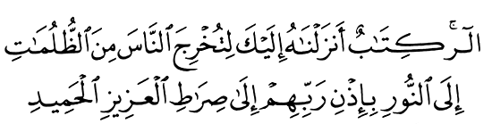
Imam - Mahdi



6 Febr 2003
Qur'an II,118

Vision for World Peace
http://www.euro-tongil.org/finnish
/english

www.euro-tongil.org/finnish/

www.euro-tongil.org/finnish/

www.euro-tongil.org/finnish/

www.euro-tongil.org/finnish/

www.euro-tongil.org/finnish/

www.euro-tongil.org/finnish/

www.euro-tongil.org/finnish/

www.euro-tongil.org/finnish/

www.euro-tongil.org/finnish/

www.euro-tongil.org/finnish/

www.euro-tongil.org/finnish/

www.euro-tongil.org/finnish/

www.euro-tongil.org/finnish/

www.euro-tongil.org/finnish/

www.euro-tongil.org/finnish/

