Lecture/Föredrag

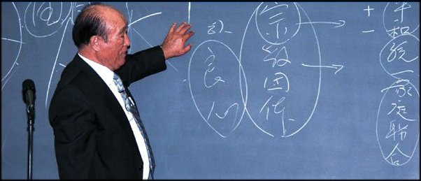

Dr Sun Myung Moon Korea

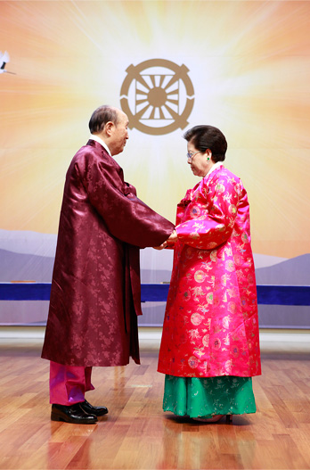

Holy Family!

DIVINE PRINCIPLE

Lecture/Discussion
Every weekend
Ravalsintie 6C16
Welcome.

PRINCIPERNA Föredrag/diskussion
Varje helg Ravalsintie 6C16
Välkomna.
0445041950

Biography in English!

/www.euro-tongil.org/swedish/english/TFbiography.pdf

/www.euro-tongil.org/swedish/english/TFbiography.pdf

/www.euro-tongil.org/swedish/english/TFbiography.pdf

/www.euro-tongil.org/swedish/english/TFbiography.pdf

/www.euro-tongil.org/swedish/english/TFbiography.pdf

/www.euro-tongil.org/swedish/english/TFbiography.pdf

/www.euro-tongil.org/swedish/english/TFbiography.pdf

/www.euro-tongil.org/swedish/english/TFbiography.pdf

/www.euro-tongil.org/swedish/english/TFbiography.pdf

/www.euro-tongil.org/swedish/english/TFbiography.pdf

Lecture/Föredrag

Dr Sun Myung Moon Korea

Holy Family!
DIVINE PRINCIPLE

Lecture/Discussion
Every weekend
Ravalsintie 6C16
Welcome.

PRINCIPERNA
Föredrag/diskussion
Varje helg Ravalsintie 6C16
Välkomna.
0445041950

Biography in English!

