Lecture/Föredrag

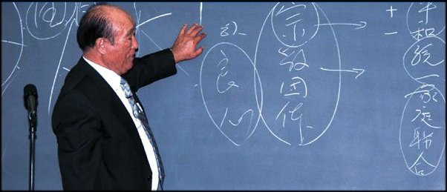

Dr Sun Myung Moon Korea

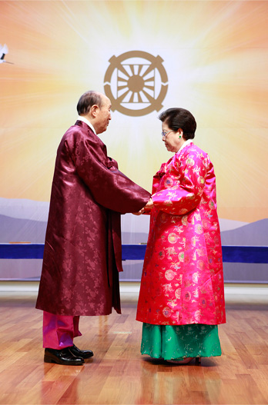

Holy Family!

DIVINE PRINCIPLE Lecture/Discussion
Every weekend Ravalsintie 6C16
Welcome.

PRINCIPERNA Föredrag/diskussion
Varje helg Ravalsintie 6C16
Välkomna.
0445041950
Biography in English!
/www.euro-tongil.org/swedish/english/TFbiography.pdf

/www.euro-tongil.org/swedish/english/TFbiography.pdf

/www.euro-tongil.org/swedish/english/TFbiography.pdf

/www.euro-tongil.org/swedish/english/TFbiography.pdf

/www.euro-tongil.org/swedish/english/TFbiography.pdf

/www.euro-tongil.org/swedish/english/TFbiography.pdf

/www.euro-tongil.org/swedish/english/TFbiography.pdf

/www.euro-tongil.org/swedish/english/TFbiography.pdf

/www.euro-tongil.org/swedish/english/TFbiography.pdf

/www.euro-tongil.org/swedish/english/TFbiography.pdf

