Hello.

Do you want your children,grandchildren, great grandchildren …
being born woithout original sin…

Do you want to build a better world…who don’t?
Amnesty, Doctors/Techers without borders, Green Peace..are allready in full process ☺

A World without Sin…an Utopia ☺
Agreable …but please read on …

It’s up to you to decide the truthfullness och this Holy Message from the Orient!

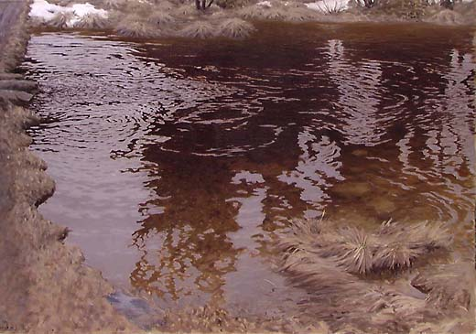

Springwater by Fjaestad, oil

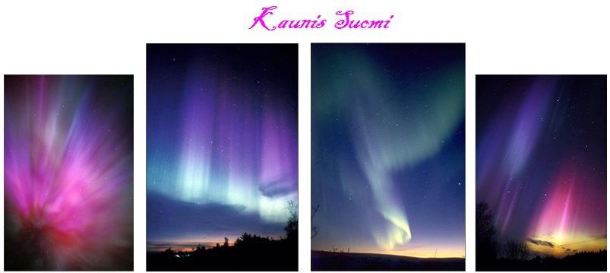
Aurora over Finland

Like the clean water of Spring, or Auroras crystallclear rays…we hope this Spiritual Light will reach your Heart and shine all over Finland and the World. :-)

References: Seond Coming in Korea

CHUNG KAM ROK
(Chung-Kam-Rok Collection. Tokyo, Japan: Ji-Yu To-Kyu-Sha, 1933)

The highlight of its prophecies of historical events is the accurate prediction of General Douglas MacArthur's successful Inchon landing operation. MacArthur was commander of the United Nations forces at that stage of the Korean War, which broke out June 25, 1950.

He also predicted the defeat of Japan in World War II and he also predicted some thousand years ago the white cross, a very significant feat.

The writings of Chung Kam Rok are estimated at roughly a thousand years old.

There will ensue an effort to continue a dynasty for a second generation in North Korea, but to no avail; it will end. Negative winds will blow at a tree from all four directions; thus it will be hard to endure.

Six multiplied by six equals thirty-six: after the thirty-six years of Japanese colonial occupation transpire, Korea will enjoy good years. A beautiful country in the east will be divided into two (one white, the other red: democratic and communist) but eventually it will be united again.

Concerning this division of one race and one nation into two. by the time of reunification and return to the original pre-division state, there will be many people starving and stricken ill.

How many will ever survive. The year of famine and starvation will recur repeatedly.

Do not ever doubt that the heavenly Holy One will descend from Heaven in the east. If the east fails to recognize the Holy One, he will come to be known through newly educated western people. If both east and west are unable to discern the Holy One who is to come, both east and west will be discarded and new humankind will emerge.

The one who is to come will establish a foundation in the early part of his life. In his middle years he will meet a pre-arranged spouse and marry again, and in his latter years (2000-2001 or 2024-2025) he will accomplish the will of God and his couple will rejoice together.

(Korean War 1950-53, divided Korea as above prophecied)

NOSTRADAMUS

The Messiah As Described In A Western Book Of Prophecy

The book of the great French prophet Nostradamus, 10:75, reads,

No matter how long we wait there is no chance that he will come from Europe. It is Asia from whence he is to come. A great union will be born out of Hermes. He will surpass all the kings of the Orient. The country of the sun will maintain a great messianic law. A new leader of the spirit will come in the east.

Thus the Bible, which transcends time and place (whether east or west, ancient times or the present day), and other prophecies are unanimous in predicting that the Messiah is surely coming in Korea.

Reference:
Who Is He?
Sung Mo Koo
August 1998

Mr Ku’s conclusion in the end of the book
"Who else then Dr. Sun Myung Moon, Korea
Can this be!"

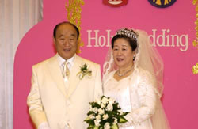

The Holy Moon Wedding Ceremoni 2003 Korea

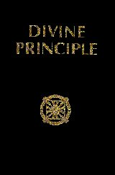

Charts from the Holy Completed Testament ”DIVINE PRINCIPLE”

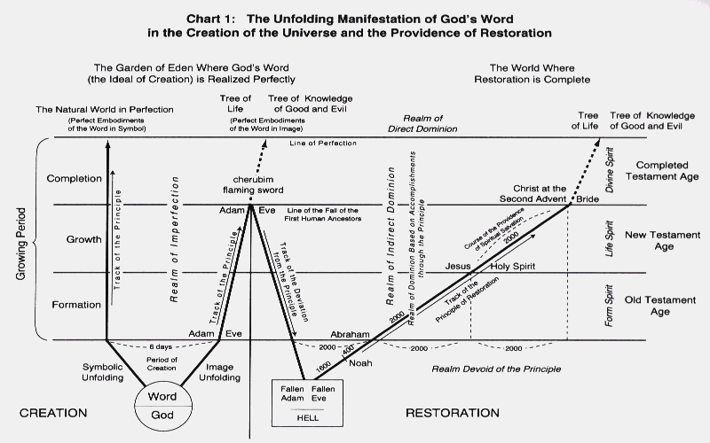

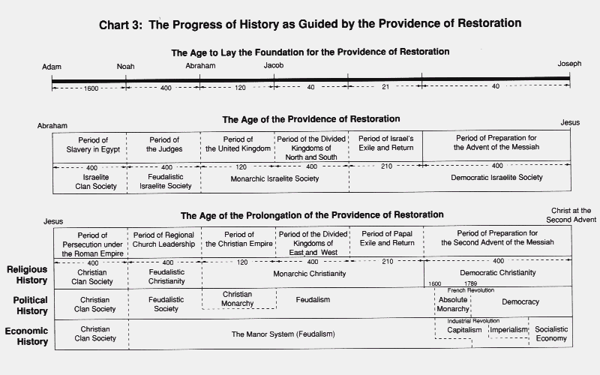

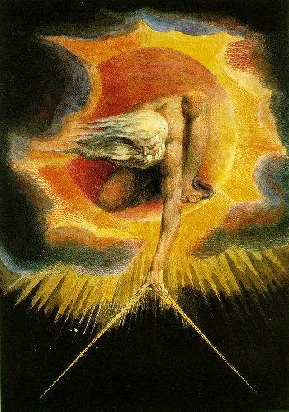
God our loving Father, according to Jesus

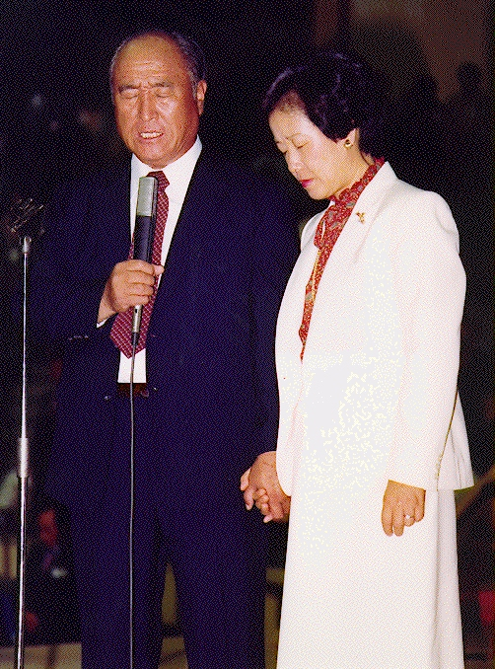

The Holy Couple Moon, Gods representatives on the Earth!
2000 years after Jesus av Nasaret

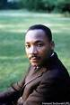

Dr. Martin Luther King

When we let freedom ring, when we let it ring from every village and every hamlet, from every state and every city, we will be able to speed up that day when all of God's children, black men and white men, Jews and Gentiles, Protestants and Catholics, will be able to join hands and sing in the words of that old Negro spiritual,
"Free at last! Free at last! Thank God almighty, we are free at last!"

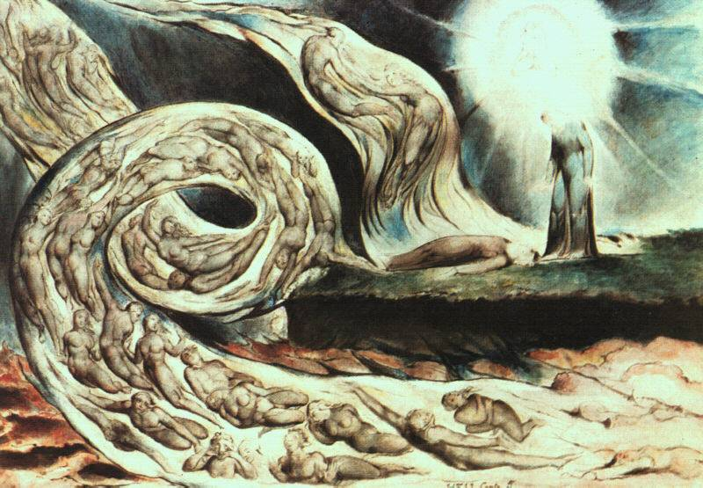

English painter and poet William Blake “Whirlwind of Lovers”

