2012
&
Kalevala
Case in point is the mysterious existence of myths obviously describing precession in the ancient verses of the Kalevala, the Finnish National Epic. These myths were relayed from the earliest times by way of singers. Many of these stories are thoroughly magical and are filled with sky lore. The Finnish language is not of Indo- European origin and up until the late 19th century peasants in Finland and northwestern Russia had little contact with Europe. Indeed, their heritage suggests more contact with Central Asia than Europe. Some of the Kalevala stories describe a sacred Mill called the Sampo (derived from sanskrit Skambha = pillar or pole) with a "many ciphered cover". This spinning Mill is a metaphor for a Golden Age of plenty and the starry sky spinning around the Pole Star (known as the Nail of the North), which in the Far North is almost straight over head. The Mill at some point is disturbed, its pillar being pulled out of its peg, and a new one - a new "age" - must be constructed. This becomes the chore of Ilmarinen, the primeval smith. In this legend, ancient knowledge of precession among unsophisticated "peasants" who were nonetheless astute skywatchers, was preserved via oral tradition almost down to modern times.
Ref: http://www.levity.com/eschaton/Why2012.html

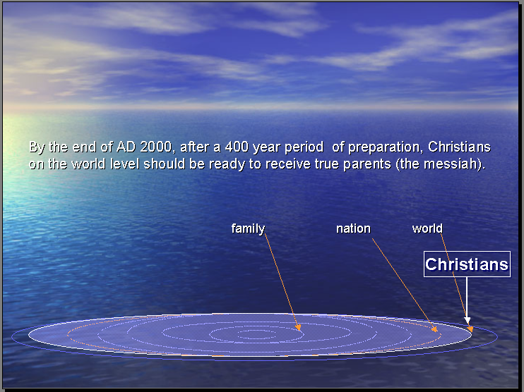

For more information, Contact Family Federation for World Peace

http://www.euro-tongil.org/finnish

/Bengt 0408382356

