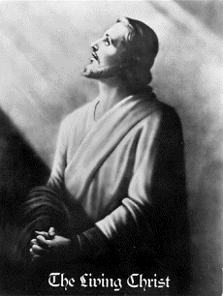

THE RETURN OF CHRIST, MESSIAH (Jews), Jesus of Nazareth suffered documented
MAHDI (Muslims), AVATAR (Hindus), MATREYA (Buddhist) rejection as the Universal

IS TAKING PLACE THROUGH A SINLESS KOREAN COUPLE Messiah 2000 years ago!
Still we know today He was the TRUE waited Son of God

THE LORD OF THE SECOND ADVENT
AND HIS BRIDE SINCE 1935
FULFILLING BIBLICAL PROPHECIES

Jesus said that the Lord will come like a thief. - Rev. 3.3
= New name "Sun Myung Moon"

But first he must suffer many things and be rejected by this
generation. -Luke 17:25 = Is he true or false?

As the lightning flashes and lights up the sky from one side
to the other, so will the Son of man be in his day. -Luke 17:24
= Internet -Satellites-Global communication

The Korean people have long cherished a messianic hope,
nurtured by the clear testimonies of their prophets.

Cheong Il Guk and NOSTRADAMUS

THE RETURN OF THE CHRIST WILL BRING World Peace

http://www.euro-tongil.org/finnish/

www.euro-tongil.org/finnish

www.euro-tongil.org/finnish

www.euro-tongil.org/finnish

www.euro-tongil.org/finnish

www.euro-tongil.org/finnish

www.euro-tongil.org/finnish

www.euro-tongil.org/finnish

www.euro-tongil.org/finnish

www.euro-tongil.org/finnish

www.euro-tongil.org/finnish

www.euro-tongil.org/finnish

www.euro-tongil.org/finnish

www.euro-tongil.org/finnish

www.euro-tongil.org/finnish

www.euro-tongil.org/finnish

www.euro-tongil.org/finnish

www.euro-tongil.org/finnish

www.euro-tongil.org/finnish

www.euro-tongil.org/finnish

www.euro-tongil.org/finnish

www.euro-tongil.org/finnish

www.euro-tongil.org/finnish

