
THE PHYSICAL RETURN OF CHRIST

Jesus Returning through a korean sinless couple!
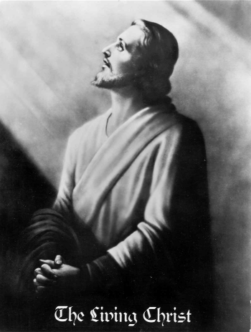

Jesus said that the Lord will come like a thief. - Rev. 3.3

But first he must suffer many things and be rejected by this generation. -Luke 17:25

As the lightning flashes and lights up the sky from one side to the other,
so will the Son of man be in his day. -Luke 17:24

Behold, he is coming with the clouds, and every eye will see him, every one who pierced him; and all
the tribes of the earth will wail on account of him. Even so. Amen. -Rev. 1:7

The Korean people have long cherished a messianic hope,
nurtured by the clear testimonies of their prophets.

THE RETURN OF CHRIST WILL BRING World Peace

www.euro-tongil.org/finnish

www.euro-tongil.org/finnish

www.euro-tongil.org/finnish

www.euro-tongil.org/finnish

www.euro-tongil.org/finnish

www.euro-tongil.org/finnish

www.euro-tongil.org/finnish

www.euro-tongil.org/finnish

www.euro-tongil.org/finnish

www.euro-tongil.org/finnish

www.euro-tongil.org/finnish

www.euro-tongil.org/finnish

www.euro-tongil.org/finnish

www.euro-tongil.org/finnish

www.euro-tongil.org/finnish

www.euro-tongil.org/finnish

www.euro-tongil.org/finnish

www.euro-tongil.org/finnish

www.euro-tongil.org/finnish

