
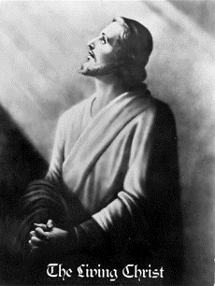

Jesus said that the Lord will come like a thief. - Rev. 3.3

But first he must suffer many things and be rejected by this
generation. -Luke 17:25

As the lightning flashes and lights up the sky from one side
to the other, so will the Son of man be in his day. -Luke 7:24

Behold, he is coming with the clouds, and every eye will see him, every one who pierced him;
and all the tribes of the earth will wail on account of him.
Even so. Amen. -Rev. 1:7

The Korean people have long cherished a messianic hope,
nurtured by the clear testimonies of their prophets.

More about True Parents, their UNITED NATION vision for World Peace

http://www.euro-tongil.org/finnish/

www.euro-tongil.org/finnish

www.euro-tongil.org/finnish

www.euro-tongil.org/finnish

www.euro-tongil.org/finnish

www.euro-tongil.org/finnish

www.euro-tongil.org/finnish

www.euro-tongil.org/finnish

www.euro-tongil.org/finnish

www.euro-tongil.org/finnish

www.euro-tongil.org/finnish

www.euro-tongil.org/finnish

www.euro-tongil.org/finnish

www.euro-tongil.org/finnish

www.euro-tongil.org/finnish

www.euro-tongil.org/finnish

www.euro-tongil.org/finnish

www.euro-tongil.org/finnish

www.euro-tongil.org/finnish

www.euro-tongil.org/finnish

www.euro-tongil.org/finnish

www.euro-tongil.org/finnish

