En messiansk biografi

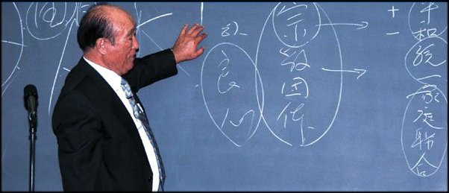

Dr Sun Myung Moon

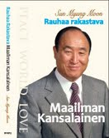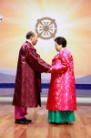

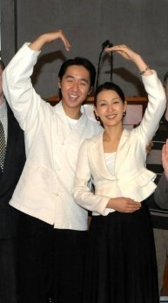
Holy Family!

/www.euro-tongil.org/swedish/english/TFbiography.pdf

/www.euro-tongil.org/swedish/english/TFbiography.pdf

/www.euro-tongil.org/swedish/english/TFbiography.pdf

/www.euro-tongil.org/swedish/english/TFbiography.pdf

/www.euro-tongil.org/swedish/english/TFbiography.pdf

/www.euro-tongil.org/swedish/english/TFbiography.pdf

/www.euro-tongil.org/swedish/english/TFbiography.pdf

/www.euro-tongil.org/swedish/english/TFbiography.pdf

/www.euro-tongil.org/swedish/english/TFbiography.pdf

/www.euro-tongil.org/swedish/english/TFbiography.pdf

