2013
Be prepared
A New World
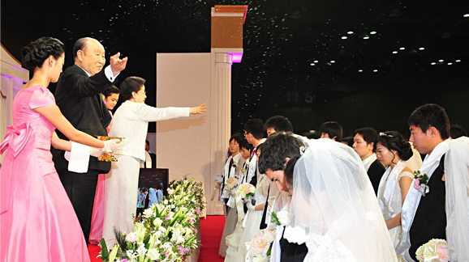
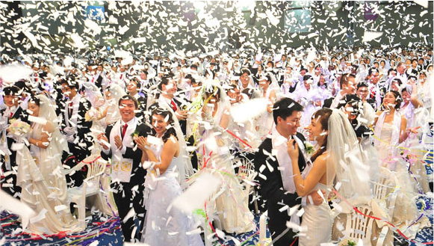

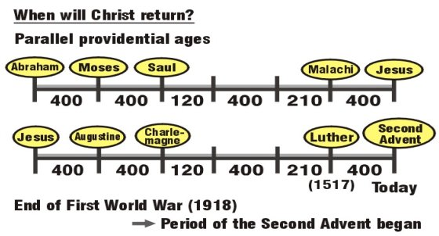

For more information, contact Family Federation for World Peace Finland

www.euro-tongil.org/
finnish/

www.euro-tongil.org/
finnish/

www.euro-tongil.org/
finnish/

www.euro-tongil.org/
finnish/

www.euro-tongil.org/
finnish/

www.euro-tongil.org/
finnish/

www.euro-tongil.org/
finnish/

www.euro-tongil.org/
finnish/

www.euro-tongil.org/
finnish/

www.euro-tongil.org/
finnish/

www.euro-tongil.org/
finnish/

www.euro-tongil.org/
finnish/

www.euro-tongil.org/
finnish/

www.euro-tongil.org/
finnish/

www.euro-tongil.org/
finnish/

www.euro-tongil.org/
finnish/

www.euro-tongil.org/
finnish/

www.euro-tongil.org/
finnish/

