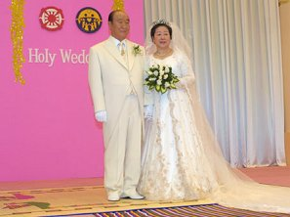 2012 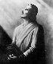
The year 2012 is being discussed more and more on Internet!

A. The ancient Mayan culture:
Why did the ancient Mayan or pre-Maya choose December 21st, 2012 A.D.,
as the end of their Long Count calendar?.
http://www.levity.com/eschaton/Why2012.html

B. The finnish ancient national epic "Kalevala"
This spinning Mill is a metaphor for a Golden Age of plenty and the starry sky spinning around the Pole Star The Mill at some point is disturbed, its pillar being pulled out of its peg,
and a new one - a new "age" - must be constructed. This becomes the chore of Ilmarinen, the primeval smith.
http://www.levity.com/eschaton/Why2012.html

C. Edgar Cayse, the most fameous american prophet
This is the time we have been all preparing for the last 13,000 years
-1998 to 2012 - a fifteen year period. If everything all the prophets
have said about that period of time come true, we are about to be
truly changed into a new kind of human.
Nostradamos and his predictions. Edgar Casey and his prophecies -
We will have entered the "Time of Change". The Solar Eclipse of Aug 11, 1999 will be the last this century. At that moment we will enter the "End of Time" until Dec 24, 2012
http://www.greatdreams.com/drun.htm

D. Doctor Sun Myung Moon, Korea
Until 2012 Father must accomplish everything in the providence of God...

Ref: http://www.unification.net/news/2003/news20030520_1.html

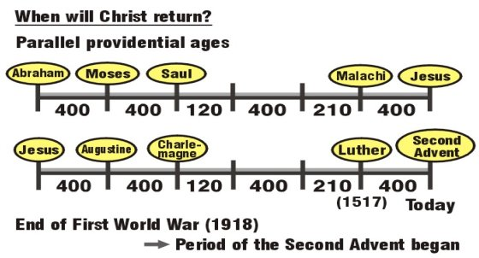

www.euro-tongil.org/finnish/

www.euro-tongil.org/finnish/

www.euro-tongil.org/finnish/

www.euro-tongil.org/finnish/

www.euro-tongil.org/finnish/

www.euro-tongil.org/finnish/

www.euro-tongil.org/finnish/

www.euro-tongil.org/finnish/

www.euro-tongil.org/finnish/

www.euro-tongil.org/finnish/

www.euro-tongil.org/finnish/

www.euro-tongil.org/finnish/

www.euro-tongil.org/finnish/

www.euro-tongil.org/finnish/

www.euro-tongil.org/finnish/

www.euro-tongil.org/finnish/

www.euro-tongil.org/finnish/

www.euro-tongil.org/finnish/

www.euro-tongil.org/finnish/

www.euro-tongil.org/finnish/

www.euro-tongil.org/finnish/

www.euro-tongil.org/finnish/

www.euro-tongil.org/finnish/

www.euro-tongil.org/finnish/

www.euro-tongil.org/finnish/

www.euro-tongil.org/finnish/

www.euro-tongil.org/finnish/

www.euro-tongil.org/finnish/

www.euro-tongil.org/finnish/

www.euro-tongil.org/finnish/

For more information, contact Family Federation for World Peace
http://www.euro-tongil.org/finnish

