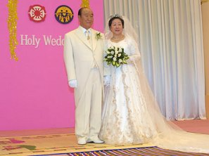 2012 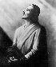
The year 2012 is being discussed more and more on Internet!

A. The ancient Mayan culture:
Why did the ancient Mayan or pre-Maya choose December 21st, 2012 A.D.,
as the end of their Long Count calendar? This article will cover some
recent research. Scholars have known for decades that the 13-baktun
cycle of the Mayan "Long Count" system of timekeeping was set to end
precisely on a winter solstice, and that this system was put in place
some 2300 years ago.
http://www.levity.com/eschaton/Why2012.html

B. The finnish ancient national epic "Kalevala"

Case in point is the mysterious existence of myths obviously
describing precession in the ancient verses of the Kalevala, the
Finnish National Epic. These myths were relayed from the earliest
times by way of singers. Some of the Kalevala stories describe a sacred
Mill called the Sampo (derived from sanskrit Skambha = pillar or pole)
with a "many ciphered cover".
This spinning Mill is a metaphor for a Golden Age of plenty and the
starry sky spinning around the Pole Star (known as the Nail of the
North), which in the Far North is almost straight over head. The Mill
at some point is disturbed, its pillar being pulled out of its peg,
and a new one - a new "age" - must be constructed. This becomes the
chore of Ilmarinen, the primeval smith. In this legend, ancient
knowledge of precession among unsophisticated "peasants" who were
nonetheless astute skywatchers, was preserved via oral tradition
almost down to modern times.
http://www.levity.com/eschaton/Why2012.html

C. Edgar Cayse, the most fameous american prophet

This is the time we have been all preparing for the last 13,000 years
-1998 to 2012 - a fifteen year period. If everything all the prophets
have said about that period of time come true, we are about to be
truly changed into a new kind of human.
So what is it about 1998 to 2012? All the prophets of the past have
pointed to this time. The Indigenous People of the World, The Native
Americans (The Hopi & the Taos Pueblo), The Hopi - The White
Brother/Sister,The Zulu Tribe in Africa believes in the coming
change.The Mayan believes by the prophecy of their elders and the
"Sixth Sun". The Seventh Sun is coming.The Japanese with the
prophecies of "Amaterasu" returning to earth at this time. Nostradamos
and his predictions. Edgar Casey and his prophecies - probably he is
the most detailed and descriptive in his prophecies.
We will have entered the "Time of Change".
The Solar Eclipse of Aug 11, 1999 will be the last this century. At
that moment we will enter the "End of Time" until Dec 24, 2012

http://www.greatdreams.com/drun.htm

D. Sun Myung Moon, Korea

· Clergy Return from Israel to East Garden of the spirit world. That
way we can set up all the ideas of
the kingdom of heaven. Until 2012 Father must accomplish everything
in the providence of God...

Ref: http://www.unification.net/news/2003/news20030520_1.html

· You should take ownership and prepare for the spirit world life War
2, so this is a crucial time and we have to accomplish the will of God
by 2010 or 2012. So you have to migrate back to your hometown and
find our own nation, ...

Ref: http://www.unification.net/2002/20020405_1.html

______________________________________________________

More references on Internet...search for 2012!
/Bengt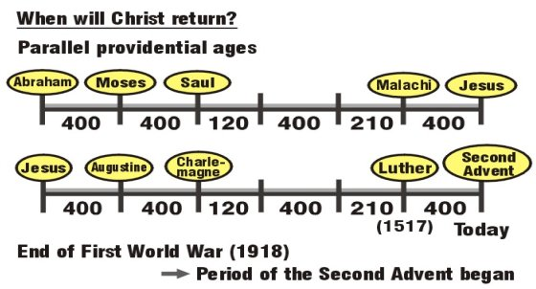

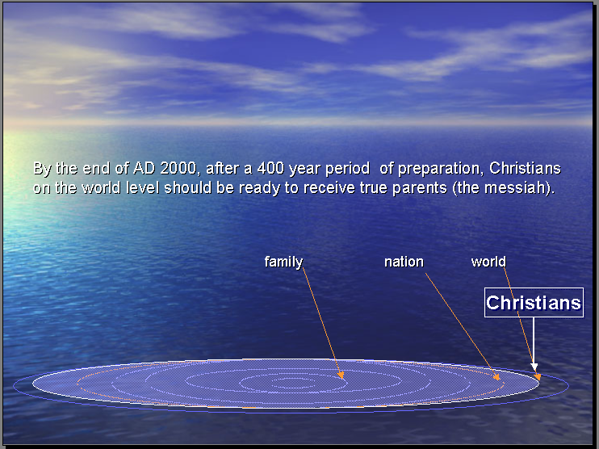

För mer information, kontakta Family Federation for World Peace
http://www.euro-tongil.org/finnish

