2000 vuotta kulunut!
Aika toinen tulossa

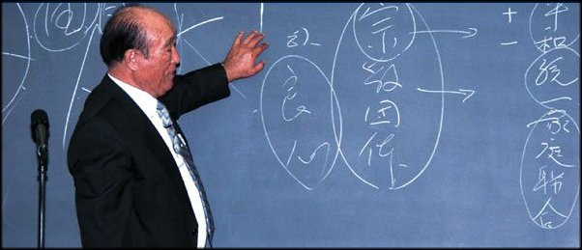
Dr Sun Myung Moon

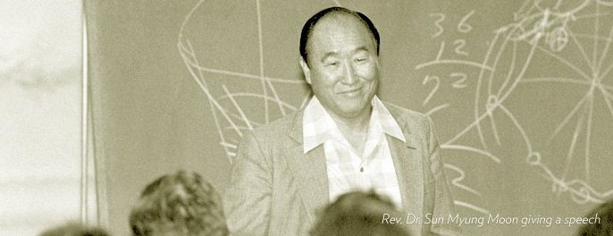

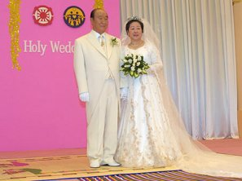
Henkistä valoa idästä!
www.euro-tongil.org/finnish/
www.euro-tongil.org/finnish/

www.euro-tongil.org/finnish/

www.euro-tongil.org/finnish/

www.euro-tongil.org/finnish/

www.euro-tongil.org/finnish/

www.euro-tongil.org/finnish/

www.euro-tongil.org/finnish/

www.euro-tongil.org/finnish/

www.euro-tongil.org/finnish/

www.euro-tongil.org/finnish/

www.euro-tongil.org/finnish/

www.euro-tongil.org/finnish/

www.euro-tongil.org/finnish/

