2000 år har gått!
Dags för den messianska återkomsten
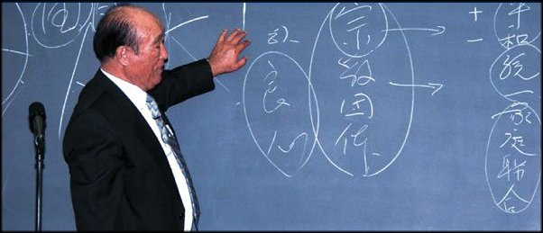
Dr Sun Myung Moon

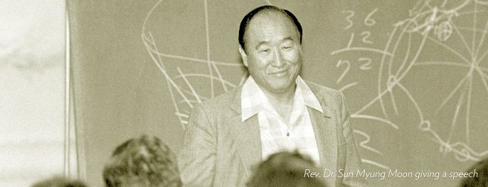

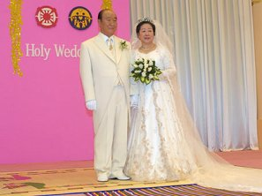
Sanna Föräldrar!
www.euro-tongil.org/swedish/

www.euro-tongil.org/swedish/

www.euro-tongil.org/swedish/

www.euro-tongil.org/swedish/

www.euro-tongil.org/swedish/

www.euro-tongil.org/swedish/

www.euro-tongil.org/swedish/

www.euro-tongil.org/swedish/

www.euro-tongil.org/swedish/

www.euro-tongil.org/finnish/

www.euro-tongil.org/finnish/

www.euro-tongil.org/finnish/

www.euro-tongil.org/finnish/

