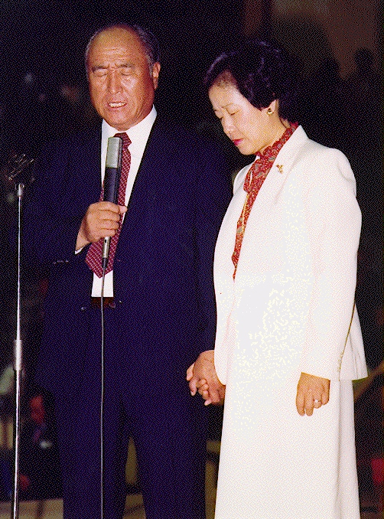
How do you understand this? Who?

Slavery in Egypt Period United Kingdom Divided Kingdom Babylonian Preparation for
of Judges Israel N/S Captivity Messiah

400 400 120 400 70+140 400

Abraham Moses Saul Malaki JESUS
12 sons blessed
70 relativs by Samuel

Persecution Regional Christian Empire Divided Kingdom Papal Exile Preparation for
in Roman Empire Church Leadership Europe E/W Messiah

400 400 120 400 70+140 400

JESUS Muhammad, Charlemagne Luther 2nd COMING
12 apostles Augustine blessed year 2000
70 disciples New. Test. by pope Leo III
Church
answer: the incredible 2nd Coming in Korea!

www.euro-tongil.org/swedish/english/
Many have prophecied: Nostradamus, Edgar Cayce, Fatima, Jeane Dixon, Martinus, W.B. Yeats, Besant, Bailey, A. Ford
How do you understand this? Who?

Slavery in Egypt Period United Kingdom Divided Kingdom Babylonian Preparation for
of Judges Israel N/S Captivity Messiah

400 400 120 400 70+140 400

Abraham Moses Saul Malaki JESUS
12 sons blessed
70 relativs by Samuel

Persecution Regional Christian Empire Divided Kingdom Papal Exile Preparation for
in Roman Empire Church Leadership Europe E/W Messiah

400 400 120 400 70+140 400

JESUS Muhammad, Charlemagne Luther 2nd COMING
12 apostles Augustine blessed year 2000
70 disciples New Test. by pope Leo III
Church
answer: the incredible 2nd Coming in Korea!
www.euro-tongil.org/swedish/english/
Many have prophecied: Nostradamus, Edgar Cayce, Fatima, Jeane Dixon, Martinus, W.B. Yeats, Besant, Bailey, A. Ford

