Nostradamus prophecies will be fulfilled
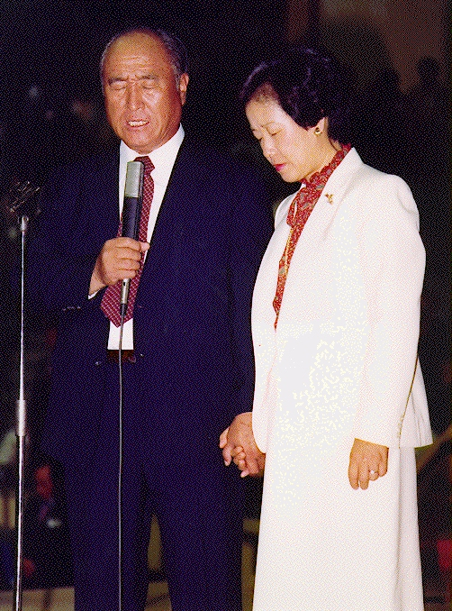
in the coming year 2000!
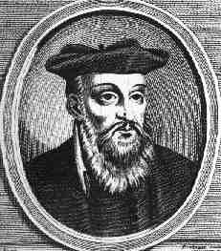

”Long awaited he will never return in Europe. Nostradamus prophesied that Christ,
He will appear in Asia; would come from the East, not Europe,
One of the league issued from great Hermes, where be has been long awaited,
He will grow above all other powers in the Orient.” and that his influence would be felt by everyone..

Read more about the Second Coming in Korea!
www.euro-tongil.org/swedish/english/

Nostradamus prophecies will be fulfilled
in the coming year 2000!
”Long awaited he will never return in Europe. Nostradamus prophesied that Christ,
He will appear in Asia; would come from the East, not Europe,
One of the league issued from great Hermes, where be has been long awaited,
He will grow above all other powers in the Orient.” and that his influence would be felt by everyone..

Read more about the Second Coming in Korea!
www.euro-tongil.org/swedish/english/

