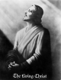
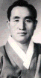
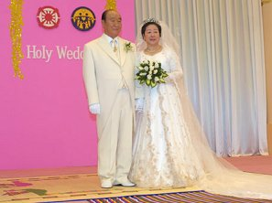
3rd Adam&Eve 2ndAdam
3 Holy People!
One Mission!
www.euro-tongil.org/swedish
3rd Adam&Eve 2ndAdam
3 Holy People!
One Mission!
www.euro-tongil.org/swedish
3rd Adam&Eve 2ndAdam
3 Holy People!
One Mission!
www.euro-tongil.org/swedish
3rd Adam&Eve 2ndAdam
3 Holy People!
One Mission!
www.euro-tongil.org/swedish

3rd Adam&Eve 2ndAdam
3 Holy People!
One Mission!
www.euro-tongil.org/swedish

3rd Adam&Eve2ndAdam
3 Holy People!
One Mission!
www.euro-tongil.org/swedish
3rd Adam&Eve2ndAdam
3 Holy People!
One Mission!
www.euro-tongil.org/swedish
3rd Adam&Eve2ndAdam
3 Holy People!
One Mission!
www.euro-tongil.org/swedish
3rd Adam&Eve2ndAdam
3 Holy People!
One Mission!
www.euro-tongil.org/swedish

3rd Adam&Eve2ndAdam
3 Holy People!
One Mission!
www.euro-tongil.org/swedish

3rd Adam&Eve 2ndAdam
3 Holy People!
One Mission!
www.euro-tongil.org/swedish
3rd Adam&Eve 2ndAdam
3 Holy People!
One Mission!
www.euro-tongil.org/swedish
3rd Adam&Eve 2ndAdam
3 Holy People!
One Mission!
www.euro-tongil.org/swedish
3rd Adam&Eve 2ndAdam
3 Holy People!
One Mission!
www.euro-tongil.org/swedish

3rd Adam&Eve 2ndAdam
3 Holy People!
One Mission!
www.euro-tongil.org/swedish

