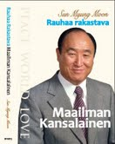
Father Moons
Biography of

TRUE LOVE
www.euro-tongil.org/
TFBiography/

Father Moons
Biography of

TRUE LOVE
www.euro-tongil.org/
TFBiography/

Father Moons
Biography of

TRUE LOVE
www.euro-tongil.org/
TFBiography/

Father Moons
Biography of

TRUE LOVE
www.euro-tongil.org/
TFBiography/


Father Moon
Power of the Spirit
www.euro-tongil.org/
TFBiography/

Father Moon
Power of the Spirit
www.euro-tongil.org/
TFBiography/

Father Moon
Power of the Spirit
www.euro-tongil.org/
TFBiography/

Father Moon
Power of the Spirit
www.euro-tongil.org/
TFBiography/

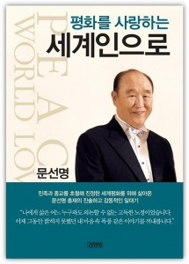
Father Moons
Biography of

TRUE LOVE
www.euro-tongil.org/
TFBiography/

Father Moons
Biography of

TRUE LOVE
www.euro-tongil.org/
TFBiography/

Father Moons
Biography of

TRUE LOVE
www.euro-tongil.org/
TFBiography/

Father Moons
Biography of

TRUE LOVE
www.euro-tongil.org/
TFBiography/

