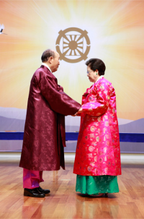
Sunday School
DivinePrinciple
Material
www.euro-tongil.org/swedish/
english/PPT/SundaySchool/

Sunday School
DivinePrinciple
Material
www.euro-tongil.org/swedish/
english/PPT/SundaySchool/

Sunday School
DivinePrinciple
Material
www.euro-tongil.org/swedish/
english/PPT/SundaySchool/

Sunday School
DivinePrinciple
Material
www.euro-tongil.org/swedish/
english/PPT/SundaySchool/

Sunday School
DivinePrinciple
Material
www.euro-tongil.org/swedish/
english/PPT/SundaySchool/

Sunday School
DivinePrinciple
Material
www.euro-tongil.org/swedish/
english/PPT/SundaySchool/

Sunday School
DivinePrinciple
Material
www.euro-tongil.org/swedish/
english/PPT/SundaySchool/

Sunday School
DivinePrinciple
Material
www.euro-tongil.org/swedish/
english/PPT/SundaySchool/

Sunday School
DivinePrinciple
Material
www.euro-tongil.org/swedish/
english/PPT/SundaySchool/

Sunday School
DivinePrinciple
Material
www.euro-tongil.org/swedish/
english/PPT/SundaySchool/

Sunday School
DivinePrinciple
Material
www.euro-tongil.org/swedish/
english/PPT/SundaySchool/

Sunday School
DivinePrinciple
Material
www.euro-tongil.org/swedish/
english/PPT/SundaySchool/

