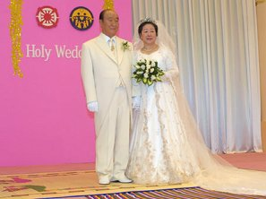

Nostradamus & the Messiah
www.euro-tongil.org /swedish
/finnish & swedish/english

Nostradamus & the Messiah
www.euro-tongil.org /swedish
/finnish & swedish/english

Nostradamus & the Messiah
www.euro-tongil.org /swedish
/finnish & swedish/english

Nostradamus & the Messiah
www.euro-tongil.org /swedish
/finnish & swedish/english
Nostradamus & the Messiah
www.euro-tongil.org /swedish
/finnish & swedish/english

Nostradamus & the Messiah
www.euro-tongil.org /swedish
/finnish & swedish/english

Nostradamus & the Messiah
www.euro-tongil.org /swedish
/finnish & swedish/english

Nostradamus & the Messiah
www.euro-tongil.org /swedish
/finnish & swedish/english

Nostradamus & the Messiah
www.euro-tongil.org /swedish
/finnish & swedish/english
Nostradamus & the Messiah
www.euro-tongil.org /swedish
/finnish & swedish/english

Nostradamus & the Messiah
www.euro-tongil.org /swedish
/finnish & swedish/english
Nostradamus & the Messiah
www.euro-tongil.org /swedish
/finnish & swedish/english

Nostradamus & the Messiah
www.euro-tongil.org /swedish
/finnish & swedish/english

Nostradamus & the Messiah
www.euro-tongil.org /swedish
/finnish & swedish/english
Nostradamus & the Messiah
www.euro-tongil.org /swedish
/finnish & swedish/english

