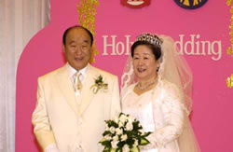
Marriage of the Lamb 2003
Rev 19:7
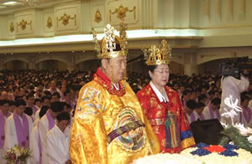

More about True Parents, their vision for World Peace
www.euro-tongil.org/swedish/finnish (also english)

Marriage of the Lamb 2003
Rev 19:7

More about True Parents, their vision for World Peace
www.euro-tongil.org/swedish/finnish (also english)

