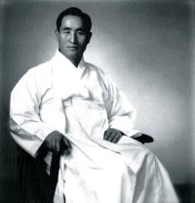

From the Orient

TRUE LOVE & BEAUTY

Vision for World Peace
www.euro-tongil.org/DP/

From the Orient

TRUE LOVE & BEAUTY
Vision for World Peace
www.euro-tongil.org/DP/

From the Orient

TRUE LOVE & BEAUTY
Vision for World Peace
www.euro-tongil.org/DP/

From the Orient

TRUE LOVE & BEAUTY
Vision for World Peace
www.euro-tongil.org/DP/

From the Orient

TRUE LOVE & BEAUTY
Vision for World Peace
www.euro-tongil.org/DP/

From the Orient

TRUE LOVE & BEAUTY
Vision for World Peace
www.euro-tongil.org/DP/

From the Orient

TRUE LOVE & BEAUTY
Vision for World Peace
www.euro-tongil.org/DP/

From the Orient

TRUE LOVE & BEAUTY
Vision for World Peace
www.euro-tongil.org/DP/

From the Orient

TRUE LOVE & BEAUTY
Vision for World Peace
www.euro-tongil.org/DP/

From the Orient

TRUE LOVE & BEAUTY
Vision for World Peace
www.euro-tongil.org/DP/

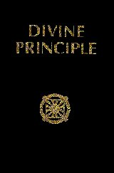
From the Orient

TRUE LOVE & BEAUTY
Vision for World Peace
www.euro-tongil.org/DP/

From the Orient

TRUE LOVE & BEAUTY
Vision for World Peace
www.euro-tongil.org/DP/

From the Orient

TRUE LOVE & BEAUTY
Vision for World Peace
www.euro-tongil.org/DP/

From the Orient

TRUE LOVE & BEAUTY
Vision for World Peace
www.euro-tongil.org/DP/

From the Orient

TRUE LOVE & BEAUTY
Vision for World Peace
www.euro-tongil.org/DP/

