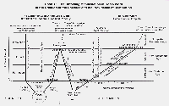
2000 YEARS!
www.euro-tongil.org/finnish

2000 YEARS!
www.euro-tongil.org/finnish

2000 YEARS!
www.euro-tongil.org/finnish

2000 YEARS!
www.euro-tongil.org/finnish

2000 YEARS!
www.euro-tongil.org/finnish

2000 YEARS!
www.euro-tongil.org/finnish

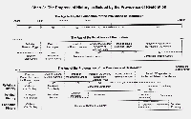
2000 YEARS!
www.euro-tongil.org/finnish

2000 YEARS!
www.euro-tongil.org/finnish

2000 YEARS!
www.euro-tongil.org/finnish

2000 YEARS!
www.euro-tongil.org/finnish

2000 YEARS!
www.euro-tongil.org/finnish

2000 YEARS!
www.euro-tongil.org/finnish

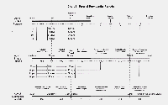
2000 YEARS!
www.euro-tongil.org/finnish

2000 YEARS!
www.euro-tongil.org/finnish

2000 YEARS!
www.euro-tongil.org/finnish

2000 YEARS!
www.euro-tongil.org/finnish

2000 YEARS!
www.euro-tongil.org/finnish

2000 YEARS!
www.euro-tongil.org/finnish

