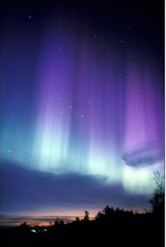
Finland

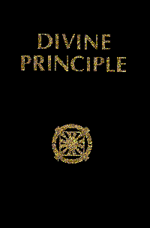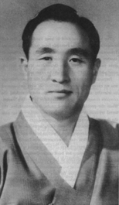

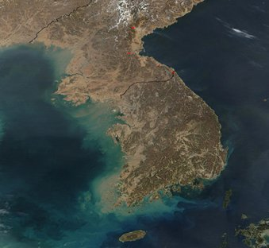
One United Korea
One United World

www.euro-tongil.org/DPFlags/

Finland

One United Korea

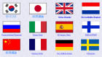
One United World
www.euro-tongil.org/DPFlags/
Finland

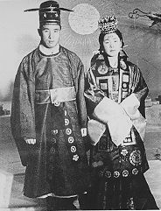
Holy Wedding 1960

www.euro-tongil.org/DPFlags/

Finland

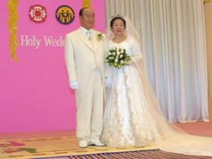
Holy Wedding 2003

One United Korea
One United World

www.euro-tongil.org/DPFlags/

Finland

One United Korea
One United World

www.euro-tongil.org/DPFlags/

Finland

One United Korea

One United World
www.euro-tongil.org/DPFlags/

