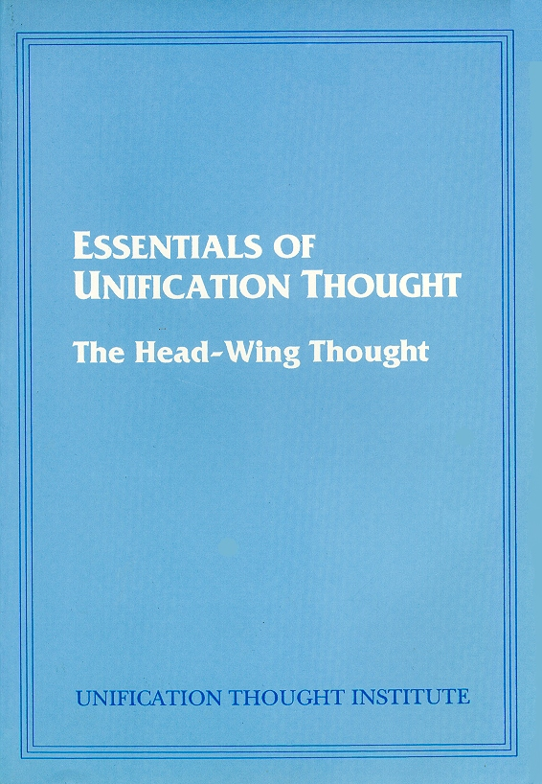
Essentials Of Unification Thought
The Head-Wing Thought

Theory of Education
Education in today's democratic society is in a dangerous state, as can be seen from the degradation of the sexual morality of youth, the frequent occurrence of school violence, and so on. Yet, a suitable theory of education to overcome this confusion is not to be found anywhere, and present-day education has lost its sense of direction. The proper relationship between teacher and student is collapsing. That is to say, students do not respect their teachers, and teachers have lost their sense of authority and enthusiasm. In consequence, the relationship between teachers and students has become one in which the teachers are selling knowledge and the students are buying it, so that schools have turned into places for buying and selling knowledge.

The new theory of education should be established on the basis of the standards that God originally intended to establish for human growth. Such a theory will give proper direction to today's education, which is in confusion, and will provide a vision of education for future society. In other words, it is a theory of education that makes preparation for the future, ideal society. The Unification Theory of Education presented here is precisely such a theory of education.
Theories of education usually have two aspects. One is concerned with the ideals, goals, methods, and so on, of education, and corresponds to what is called the philosophy of education. The other deals with education as an objective, observable phenomenon, and is called the science of education. The science of education inquires into school curricula, student evaluation and testing, learning techniques, student counseling, school administration, educational management, and so forth.
These two fields are in the relationship of Sungsang and Hyungsang. The philosophy of education is the Sungsang of education, whereas the science of education is the Hyungsang of education. While the science of education has made great advances under the modern tendency to think highly of science, the philosophy of education is being neglected and is steadily declining. The fact that education today has lost its direction implies the absence of a philosophy of education. Therefore, what is urgently needed today is the establishment of a new philosophy of education. Therefore, to fill the need for a new philosophy of education, the Unification Theory of Education is hereby proposed.

The Korean people have long cherished a messianic hope,
nurtured by the clear testimonies of their prophets.

THE RETURN OF CHRIST WILL BRING World Peace

www.euro-tongil.org/finnish

www.euro-tongil.org/finnish

www.euro-tongil.org/finnish

www.euro-tongil.org/finnish

www.euro-tongil.org/finnish

www.euro-tongil.org/finnish

www.euro-tongil.org/finnish

www.euro-tongil.org/finnish

www.euro-tongil.org/finnish

www.euro-tongil.org/finnish

www.euro-tongil.org/finnish

www.euro-tongil.org/finnish

www.euro-tongil.org/finnish

www.euro-tongil.org/finnish

www.euro-tongil.org/finnish

www.euro-tongil.org/finnish

www.euro-tongil.org/finnish

www.euro-tongil.org/finnish

www.euro-tongil.org/finnish

