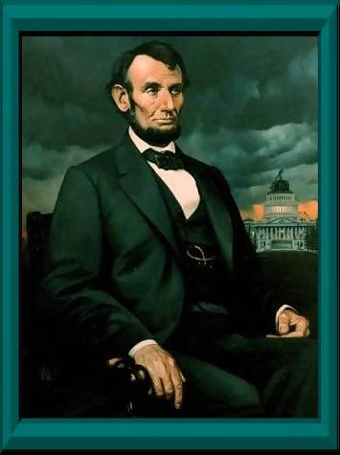
Abraham Lincoln (1861-1865)

People of America, I wish for you to constantly go the way of obedience, aligned with the teachings of True Parents.
Rev. Sun Myung Moon, Mansei!

Rev. Sun Myung Moon, I respect you. I thank you very much for all you have done. I will attend you resolutely as the Messiah and returning Lord, tear down the walls between races and religious groups, and participate actively in True Parents' Unification Movement.

Abraham Lincoln December 9, 2002

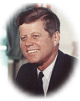
President

John Fitzgerald Kennedy (1961-1963)

A Message to the United Nations
Those of you at the United Nations, I am John Kennedy!
I declare the following:
- God is the parent of humankind and truly does exist.
- After people finish their life on earth, their soul continues on to live in the eternal world, namely the incorporeal world (spirit world) which is a reality.
Rev. Sun Myung Moon is the Messiah, the Savior and the True Parent of humankind.

John Kennedy July 30, 2003
More information
www.unification.net/leesanghun/

THE RETURN OF CHRIST WILL BRING World Peace

www.euro-tongil.org/finnish

www.euro-tongil.org/finnish

www.euro-tongil.org/finnish

www.euro-tongil.org/finnish

www.euro-tongil.org/finnish

www.euro-tongil.org/finnish

www.euro-tongil.org/finnish

www.euro-tongil.org/finnish

www.euro-tongil.org/finnish

www.euro-tongil.org/finnish

www.euro-tongil.org/finnish

www.euro-tongil.org/finnish

www.euro-tongil.org/finnish

www.euro-tongil.org/finnish

www.euro-tongil.org/finnish

www.euro-tongil.org/finnish

www.euro-tongil.org/finnish

www.euro-tongil.org/finnish

www.euro-tongil.org/finnish

www.euro-tongil.org/finnish

www.euro-tongil.org/finnish

www.euro-tongil.org/finnish

www.euro-tongil.org/finnish

www.euro-tongil.org/finnish

www.euro-tongil.org/finnish

www.euro-tongil.org/finnish

www.euro-tongil.org/finnish

www.euro-tongil.org/finnish

www.euro-tongil.org/finnish

www.euro-tongil.org/finnish

www.euro-tongil.org/finnish

www.euro-tongil.org/finnish

www.euro-tongil.org/finnish

www.euro-tongil.org/finnish

www.euro-tongil.org/finnish

www.euro-tongil.org/finnish

www.euro-tongil.org/finnish

www.euro-tongil.org/finnish

