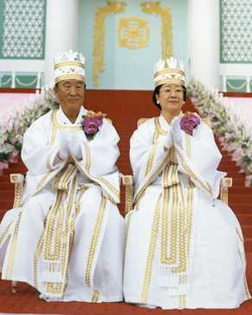
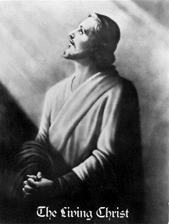

THE RETURN OF CHRIST, MESSIAH (Jews), IMAM/MAHDI (Muslims), MAITREYA (Budhists)
IS TAKING PLACE RIGHT NOW THROUGH A SINLESS KOREAN COUPLE

THE LORD OF THE SECOND ADVENT AND HIS BRIDE
FULFILLING BIBLICAL PROPHECIES SINCE 1935

Jesus said that the Lord will come like a thief. - Rev. 3.3
New Name = SunMyungMoon

But first he must suffer many things and be rejected by this
generation. -Luke 17:25
Is He true or false?
As the lightning flashes and lights up the sky from one side
to the other, so will the Son of man be in his day. -Luke 17:24
Internet - Satellites - Global Communication

The Korean people have long cherished a messianic hope,
nurtured by the clear testimonies of their prophets.

Cheong Il Guk
and NOSTRADAMUS

Are you going to hang him on the cross again, like the Romans who persecuted me 2,000 years ago? Aren't you aware of the destruction of Sodom and Gomorrah? God is love. He is waiting. Please receive the Messiah who has descended in the Completed Testament Age. Do not reject his achievements and his dispensation for the salvation of humanity. Pray with sincerity. I, Jesus, will be with you in your earnest prayers.
/Jesus Christ April 5, 2001

If this korean couple is the "Spiritual Light from the East"
then these are their signs:
INDEPENDENT confirmations on Their role as a World Saviours!
THE RETURN OF CHRIST WILL BRING World Peace
http://www.euro-tongil.org/finnish/

www.euro-tongil.org/finnish

www.euro-tongil.org/finnish

www.euro-tongil.org/finnish

www.euro-tongil.org/finnish

www.euro-tongil.org/finnish

www.euro-tongil.org/finnish

www.euro-tongil.org/finnish

www.euro-tongil.org/finnish

www.euro-tongil.org/finnish

www.euro-tongil.org/finnish

www.euro-tongil.org/finnish

www.euro-tongil.org/finnish

www.euro-tongil.org/finnish

www.euro-tongil.org/finnish

www.euro-tongil.org/finnish

www.euro-tongil.org/finnish

www.euro-tongil.org/finnish

www.euro-tongil.org/finnish

www.euro-tongil.org/finnish

www.euro-tongil.org/finnish

www.euro-tongil.org/finnish

www.euro-tongil.org/finnish

